**PROJECT REPORT ON**

**Car Parking System**

Submitted to

Department of Computer Applications

in partial fulfillment for the award of the degree of

**MASTER OF COMPUTER APPLICTIONS**

**Batch (2019-2021)**

***Submitted by***

Name of the student: Vikram Singh

Enrollment Number:19111824

**Under the Guidance of**

Mrs.Neelam Singh



GRAPHIC ERA UNIVERSITY DEHRADUN

June -2020



**CANDIDATE’S DECLARATION**

I hereby certify that the work presented in this project report entitled “Car Parking System**”** in partial fulfilment of the requirements for the award of the degree of Bachelor of Computer Application is a bonafide work carried out by me during the period of January 2020 to June 2020 under the supervision of Mrs.Neelam Singh, Department of Computer Application, Graphic Era University, Dehradun, India.

This work has not been submitted elsewhere for the award of a degree/diploma/certificate.

**Name and Signature of Candidate**

This is to certify that the above mentioned statement in the candidate’s declaration is correct to the best of my knowledge.

**Date: 18/06/2020 Name and Signature of Guide**

**Signature of Supervisor Signature of External Examiner**

**HOD**

June -2020

**CERTIFICATE OF ORIGINALITY**

This is to certify that the project report entitled “Car Parking System” submitted to **Graphic Era University, Dehradun** in partial fulfilment of the requirement for the award of the degree of **MASTER OF COMPUTER APPLICATIONS (MCA)**, is an authentic and original work carried out by Mr Vikram Singh with enrolment number 19111824 under my supervision and guidance.

The matter embodied in this project is genuine work done by the student and has not been submitted whether to this University or to any other University / Institute for the fulfilment of the requirements of any course of study.

Vikram Singh Mrs.Neelam Singh

Signature of the Student: Signature of the Guide

Date : 18-06-2020 Date:18-06-2020

Enrolment No.: 19111786

Name and Address Name, Designation and

of the Student: Address of the Guide:

Vikram SIngh Mrs.Neelam Singh

Singhal Farm Gopipuram

Halduchaur,Lalkua(Nainital).

**Acknowledgement**

First of all, my sincere and wholehearted gratitude to my the god, the almighty, for his showers of blessing throughout my research work to complete the research successfully.

I am extremely grateful to my parents for their love, players,caring and sacrifices for educating and preparing me for my future.

I have taken efforts in this project. However, it would not have been possible without the kind support and help of many individuals and organizations. I would like to extend my sincere thanks to all of them.

I am highly indebted to Mrs. Neelam Singh Mam for their guidance and constant supervision as well as for providing necessary information regarding the project & also for their support in completing the project.

I would like to express my gratitude towards my project team & member of Graphic Era University for their kind co-operation and encouragement which help me in completion of this project.

**Table of Contents**

Candidate’s Declaration2

Certificate of originality 3

Acknowledgement 4

Tables of contents 5

**1. Definition, Acronyms and Abbreviations**  **8**

**2. Abstract 9**

**3. Project category 10**

3.1 Web project 10

3.2 Web based project purpose 10

**4. Objective of project 11**

**5. Application of the project 12**

**6. Proposed system 12**

**7. Need for developing the project 13**

**8. About front end 14**

8.1 Architecture of front end user 15

8.2 Architecture and concepts 15

8.3 Flexible storage:various storage handler 16

8.4 Unique approach to caching 17

**9. Software and tools used 17**

9.1 php 17

9.1.1 Basic php syntax 19

9.2 Html 20

9.3 css 24

9.3.1 Advantage of css 25

9.4 Java script 26

9.4.1 Client side java script 27

9.5 About Ajax 29

9.5.1 Rich internet application technology 30

9.6 What is Bootstrap 32

9.6.1 History of bootstrap 32

**10. About back end 35**

10.1 My sql logical Architecture 35

10.2 My sql 37

10.2.1 Introduction 38

10.2.2 Reason to use my sql 39

**11. xampp 41**

**12. System analysis 42**

**13. Need of identification 43**

**14. Feasibility study 44**

**15. SRS 46**

15.1 General description 47

15.2 Specific requirements 48

**16. Hardware and software requirements 49**

16.1 Hardware requirements 49

16.2 Software requiremens 50

**17. Use case diagram 50**

17.1 Use case for admin 51

17.2 Use case for operator 53

**18. System design 55**

18.1 Conceptual design 56

18.2 Technical design 56

18.3 Structural design 56

**19. Database design 57**

**20. E-R diagram 60**

**21. Data flow diagram 62**

21.1 Symbol used in DFD 62

0 level dfd 63

1 level dfd 64

2 level dfd 65

**22. Website all pages 68**

**23. Advantages of car parking system implementation 84**

**24. Final result and conclusion 85**

**25. Limitation of our project 85**

**26. Future scope of our project 85**

**27. Bibliography 86**

**28. References 86**

**1 . Definition, Acronyms and Abbreviations:**

ADMIN: Administrator.

RAM: Random access memory.

ROM: Read only memory.

SRS: Software Requirement and Specification.

DFD: Data Flow Diagram.

E-RD: Entity Relationship Diagram.

OS: Operating System.

DBMS: Database Management System.

PHP: Hypertext preprocessor.

SQL: Structured Query Language.

HTML: Hyper Text Markup Language.

CSS: Cascade Style Sheet.

JS: Java Script.

HDD: Hard Disk Drive.

DD: Data Dictionary.

# 2.A****BSTRACT****

Welcome to the “CAR PARKING SYSTEM” project report a Hands-on instruction book to help you attain fluency with the software and this project in the shortest time possible. We believe that this report is unique and a welcome addition.

# **The project undertaken here is in concern with Car Parking System. This project is coded in html, css, javascript, ajax and php as a front-end and back-end mysql server, a powerful database program that will generally enhance your database capabilities.**

Car Parking System is software that acts as to manage the records related to car parking, mainly car check-in, check-out of the users. It saves a lot of time, efforts and money. Moreover it provides quick & efficient services to the user.

Maintained to fulfill the present and future needs of stock management of computer accessories. This software will automate the “**Car Parking System**” using computer system instead of manual system. This project is concerned with the car parking related information.

There are some functions:-

* Maintaining the record of cars checked in and checked out.
* Updating the record.
* Can get updated record.
* This project will help to know about the present status of Parking slots.
* This project will be automate the Car Parking System to help

Managing parking related information (check-in, check-out, operators, etc).

This project is highly helpful in the fulfillment of the requirements of Parking record maintenance. The prime object is to semi automate the whole manual procedure of data entry in such a way that one can understand it very well.

**3 .PROJECT CATEGORY**

3.1 WEB PROJECT

DESCRIPTION

A system development methodology refers to the framework that is used to structure plan and control the process of developing an information system. A wide variety of such frameworks have evolved over the years. each with its own recognized strengths and weaknesses. One system development methodology is not necessarily suitable for use by all projects.

So as per our requirement for web based approach we have selected DYNAMIC WEB PROJECT (using mysql, php, java script, bootstrap, html,css) .Web-based Information Systems Development methodology has derived a concept from hypermedia development methodology.

Hyperlink in order to provide a cross reference and navigation to other pages or sections of the application. Any hypermedia design and development methodology should be able to adopt the development of a Web-based Information Systems.

3.2 WEB BASED PROJECT PURPOSE

Firstly, the original purpose of Web-based development is to build an alternative type of medium that extends a channel of communication to online publishing purpose for internal and external stakeholders. In addition, the purpose of the Information Systems development is to facilitate business transactions and operation of an organization.

Secondly, the development life cycle of a general Information System is a long term cycle, while a short term life-cycle of web-based development is quite common for many web-based projects. Thirdly, the web is content intensive, and composed of unstructured information use; while structured information and its flow are the major focus of traditional Information Systems

**4. OBJECTIVE OF THE PROJECT**

With the fast development of computer technology, the software projects are growing in size and complexity. Software experts have recently sought to develop a more systematic and formal approach in the design, development and implementation of their software. This new approach has become necessary because the traditional methods of system development often yielded software characterized by late diversity, unreliability, and non maintainability and nonuse ability.

In this new age of computing everything has become computerized, so how can we become isolate and untouched from this environment. That’s why keeping in mind this, and an opportunity or probably a creativity to do such a task different and unique from others, we thought a way to develop this software.

This project has been developed in aim to provide a facility for Car Parking System. This system is designed in favour of the records related to parking made which helps operator to maintain them properly and efficiently.

This software is intended to automate the current manual system. Main feature of this automated system is that it takes over the system with greater efficiency and accuracy.

The main goal of this software is make it operator friendly. Using this software operator can easily maintain the large volume of data for future prospects. They are able to insert data save to database.

The objectives of the project are as follows :-

* The software is developed to overcome the limitation in managing the parking record maintenance by manual approach.
* The software is developed for smooth functioning.
* To handle large amount of data that is a tedious job in case of manual system.
* To avoid the delay in managing, searching and report designing for candidate records, this is time consuming in case of manual system.
* To increase record efficiency and reliability.
* To reduce the efforts involved in processing.

To answer the queries related to check in, check out, enquiry and manage operators.

# 5. APPLICATIONS OF THE PROJECT

# The project can be implemented in commercial areas for employee parking.

# It can be utilized by companies and organizations (hospitals, schools, colleges) to automate their parking system.

# The system can also be used in public places for public parking like in malls, station, and so on.

**6. PROPOSED SYSTEM:**

The scope of this system is to provide user efficient working environment and more output can be generated through this. This system provides user friendly interface resulting in knowing each and every usability features of the system.

This system helps in tracking records so that past records can be verified through them and one can make decisions based on the past records. This system completes the work in a very less time resulting in less time consumption and high level of efficiency.

This system is developed in such a way that even a naïve user can also operate the system easily. The calculations are made very quickly and the records are directly saved into databases and the databases can be maintained for a longer period of time. Each record can be retrieved and can be verified for the future needs and for future transactions.

Also this system provides high level of security for data leaking as only admin people can access the database no changes can be made in it until it verifies the user login id and password.

Identification of the drawbacks of the existing system leads to the designing of computerized system that will be better to the existing system which is more users friendly and GUI oriented. We can improve the efficiency of the system, thus overcome the drawbacks of the existing system.

* Less human error
* Strength and strain of manual labour can be reduced
* High security
* Data consistency
* Easy to handle
* Easy data updating
* Easy record keeping.
* Backup data can be easily generated.
* To generate various reports like stock enquiry, stock-in details, stock-out details etc
* Provide search facility like search by id and search by name.

**7. NEED FOR DEVELOPING THE PROJECT**

At present the information regarding car parking, parking details and searching of the parking records are done manually. Thus there is inconsistency in record keeping and data managementwhich can be easily avoided by the usage of computerised system of the manual work. This particular project deals with the problems on managing and generating the reports and avoids the problems which occur when carried manually.

Identification of the drawbacks of the existing system leads to the designing of computerized system that will be better in performance as compared to with the existing system, it is more users friendly and GUI oriented. We can improve the efficiency of the system, thus overcome the drawbacks of the existing system.

# 8. ABOUT FRONT END-

The front end is an [interface](https://en.wikipedia.org/wiki/Interface_(computer_science)) between the user and the back end. The front and back ends may be distributed amongst one or more systems.

In [network computing](https://en.wikipedia.org/wiki/Computer_network), *front end* can refer to any hardware that optimizes or protects network traffic. It is called [application front-end hardware](https://en.wikipedia.org/wiki/Denial_of_service#Application_front_end_hardware) because it is placed on the network's outward-facing front end or boundary. Network traffic passes through the front-end hardware before entering the network.

In [compilers](https://en.wikipedia.org/wiki/Compilers), the [front end](https://en.wikipedia.org/wiki/Compilers#Front_end) translates a computer programming [source code](https://en.wikipedia.org/wiki/Source_code) into an [intermediate representation](https://en.wikipedia.org/wiki/Intermediate_representation), and the back end works with the intermediate representation to produce code in a computer output language. The back end usually optimizes to produce code that runs faster. The front-end/back-end distinction can separate the [parser](https://en.wikipedia.org/wiki/Parsing) section that deals with source code and the back end that [generates code and optimizes](https://en.wikipedia.org/wiki/Code_generation_(compiler)).

These days, front-end development refers to the part of the web users interact with. In the past, web development consisted of people who worked with Photoshop and those who could code HTML and CSS. Now, developers need a handle of programs like Photoshop and be able to code not only in HTML and CSS, but also JavaScript or jQuery, which is a compiled library of JavaScript.

Most of everything you see on any website is a mixture of HTML, CSS, and JavaScript, which are all controlled by the browser. For example, if you’re using Google Chrome or Firefox, the browser is what translates all of the code in a manner for you to see and with which to interact, such as fonts, colors, drop-down menus, sliders, forms, etc. In order for all of this to work, though, there has to be something to support the front-end; this is where the backend comes into play.

**8.1 Architecture of Front End user:**

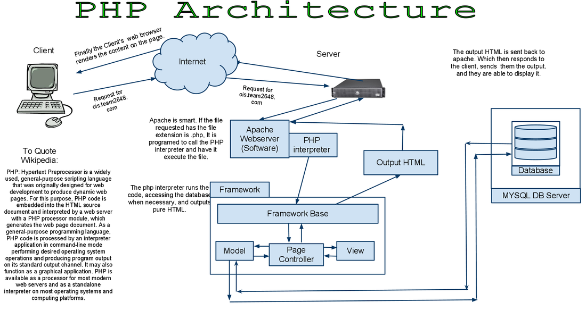

**8.2 Architecture and Concepts**

The query cache plugin is implemented as a PHP extension. It is written in C and operates under the hood of PHP. During the startup of the PHP interpreter, it gets registered as a [mysqlnd](http://php.net/manual/en/book.mysqlnd.php) plugin to replace selected mysqlnd C methods. Hereby, it can change the behaviour of any PHP MySQL extension ([mysqli](http://php.net/manual/en/ref.mysqli.php), [PDO_MYSQL](http://php.net/manual/en/ref.pdo-mysql.php), [mysql](http://php.net/manual/en/ref.mysql.php)) compiled to use the mysqlnd library without changing the extensions API. This makes the plugin compatible with each and every PHP MySQL application. Because existing APIs are not changed, it is almost transparent to use. Please, see the [mysqlnd plugin API description](http://php.net/manual/en/mysqlnd.plugin.php) for a discussion of the advantages of the plugin architecture and a comparison with proxy based solutions.

**Transparent to use**

At PHP run time PECL/mysqlnd_qc can proxy queries send from PHP ([mysqlnd](http://php.net/manual/en/book.mysqlnd.php)) to the MySQL server. It then inspects the statement string to find whether it shall cache its results. If so, result set is cached using a storage handler and further executions of the statement are

served from the cache for a user-defined period. The Time to Live (TTL) of the cache entry can either be set globally or on a per statement basis.

A statement is either cached if the plugin is instructed to cache all statements globally using a or, if the query string starts with the SQL hint (*/*qc=on*/*). The plugin is capable of caching any query issued by calling appropriate API calls of any of the existing PHP MySQL extensions.

**8.3 Flexible storage: various storage handler**

Various storage handler are supported to offer different scopes for cache entries. Different scopes allow for different degrees in sharing cache entries among clients.

1. *default* (built-in): process memory, scope: process, one or more web requests depending on PHP deployment model used
2. *APC*: shared memory, scope: single server, multiple web requests
3. *SQLite*: memory or file, scope: single server, multiple web requests
4. *MEMCACHE*: main memory, scope: single or multiple server, multiple web requests
5. *user* (built-in): user-defined - any, scope: user-defined - any

Support for the *APC*, *SQLite* and *MEMCACHE* storage handler has to be enabled at compile time. The *default* and *user* handler are built-in. It is possible to switch between compiled-in storage handlers on a per query basis at run time. However, it is recommended to pick one storage handler and use it for all cache entries.

**Built-in slam defense to avoid overloading**

To avoid overload situations the cache plugin has a built-in slam defense mechanism. If a popular cache entries expires many clients using the cache entries will try to refresh the cache entry. For the duration of the refresh many clients may access the database server concurrently. In the worst case, the database server becomes overloaded and it takes more and more time to refresh the cache entry, which in turn lets more and more clients try to refresh the cache entry. To prevent this from happening the plugin has a slam defense mechanism. If slam defense is enabled and the plugin detects an expired cache entry it extends the life time of the cache entry before it refreshes the cache entry. This way other

concurrent accesses to the expired cache entry are still served from the cache for a certain time.The other concurrent accesses to not trigger a concurrent refresh. Ideally, the cache entry gets refreshed by the client which extended the cache entries lifespan before other clients try to refresh the cache and potentially cause an overload situation.

**8.4 Unique approach to caching**

PECL/mysqlnd_qc has a unique approach to caching result sets that is superior to application based cache solutions. Application based solutions first fetch a result set into PHP variables. Then, the PHP variables are serialized for storage in a persistent cache, and then unserialized when fetching. The mysqlnd query cache stores the raw wire protocol data sent from MySQL to PHP in its cache and replays it, if still valid, on a cache hit. This way, it saves an extra serialization step for a cache put that all application based solutions have to do. It can store the raw wire protocol data in the cache without having to serialize into a PHP variable first and deserializing the PHP variable for storing in the cache a

**9. Software & Tools Used:**

**9.1 PHP:-**

**Introduction**

PHP is now officially known as “**PHP: Hypertext Preprocessor**”. It is a server-side scripting language usually written in an HTML context. Unlike an ordinary HTML page, a PHP script is not sent directly to a client by the server; instead, it is parsed by the PHP binary or module, which is server-side installed. HTML elements in the script are left alone, but PHP code is interpreted and executed. PHP code in a script can query databases, create images, read and write files, talk to remote servers – the possibilities is endless. The output from PHP code is combined with the HTML in the script and the result sent to the user’s web-browser, therefore it can never tell the user whether the web-server uses PHP or not, because the entire browser sees is HTML.

PHP’s support for Apache and MySQL further increases its popularity. Apache is now the most-used web-server in the world, and PHP can be compiled as an Apache module. MySQL is a powerful free SQL database, and PHP provides a comprehensive set of functions for working with it. The combination of Apache, MySQL and PHP is all but unbeatable.

That doesn’t mean that PHP cannot work in other environments or with other tools. In fact, PHP supports an extensive list of databases and web-servers. While in the mid-1990s it was ok to build sites, even relatively large sites, with hundreds of individual hard-coded HTML pages, today’s webmasters are making the most of the power of databases to manage their content more effectively and to personalize their sites according to individual user preferences.

## Reasons for using PHP

There are some indisputable great reasons to work with PHP. As an open source product, PHP is well supported by a talented production team and a committed user community. Furthermore, PHP can be run on all the major operating systems with most servers.

**a)Learning PHP is easy**

Basic is easy any interpreted language should be easy to learn. Since you are isolated from the system (no pointers to use, no memory to allocate). The other advantage that all modern interpreted languages share is good associative array constructs.

**b)Its Performance**

While we can build an application that serves millions of pages a day on a server, when we really look at the performance of the language it sucks. We are still orders of magnitude from real performance. Not only that, but since PHP is designed around a single process model our ability to share data structures or connection pool resources is left to native code libraries.

**c)The low cost**

There are many languages which are available at very less cost. There are some languages which are available at very less cost like below:

* 1. PHP
  2. C
  3. C++ etc

**d**) **It’s Open Source, We can modify it**

We can modify it if you need a hole in your head! Technically the point is that it’s an open source project and they release patches often. You’re point is that the community is actively working out the bugs. So, what any active language is doing this...

Unfortunately C, C++ and Perl have all “died” at this point and will pretty much remain static at their current functionality.

**e)Its Portability**

C is portable; it’s just the OS bits that aren’t. A lot PHP isn’t portable to Windows since people don’t use the OS abstractions to avoid some problems.

**F)It has interfaces to a large variety of database systems**

PHP supports a large variety of the database.

**Support available**

Online Support is available for using PHP.

1. **PHP Syntax**

You cannot view the PHP source code by selecting “View source” in the browser – you will only see the output from the PHP file, which is plain HTML. This is because the scripts are executed on the server before the result is sent back to the browser.

**9.1.2 Basic PHP Syntax**

A PHP scripting block always starts with **<?php** and ends with **?>**. A PHP scripting block can be placed anywhere in the document. On servers with shorthand support enabled you can start a scripting block with <? And end with ?>. However, for maximum compatibility, we recommend that you use the standard form (<?php) rather than the shorthand form.

A PHP file normally contains HTML tags, just like an HTML file, and some PHP scripting code.

**9.2 HTML**

**HTML** or **Hyper Text Markup Language** is the standard markup language used to create web pages.

HTML was created in 1991 by Tim Berners-Lee at CERN in Switzerland. It was designed to allow scientists to display and share their research.

HTML is written in the form of HTML elements consisting of *tags* enclosed in angle brackets(like <html>). HTML tags most commonly come in pairs like <h1> and </h1>, although some tags represent *empty elements* and so are unpaired, for example <img>. The first tag in a pair is the *start tag*, and the second tag is the *end tag* (they are also called *opening tags* and *closing tags*).

The purpose of a web browser is to read HTML documents and compose them into visible or audible web pages. The browser does not display the HTML tags, but uses the tags to interpret the content of the page. HTML describes the structure of a website semantically along with cues for presentation, making it a markup language rather than a programming language.

HTML elements form the building blocks of all websites. HTML allows images and objects to be embedded and can be used to create interactive forms. It provides a means to create structured documents by denoting structural semantics for text such as headings, paragraphs, lists, links, quotes and other items. It can embed scripts written in languages such as Java Script which affect the behavior of HTML web pages.

HTML is descriptive markup language. Library of various markup languages is defined in various browsers.

**a) HTML Images - The <img> Tag and the Src Attribute**

In HTML, images are defined with the <img> tag.

The <img> tag is empty, which means that it contains attributes only, and has no closing tag.

To display an image on a page, you need to use the src attribute. Src stands for "source". The value of the src attribute is the URL of the image you want to display.

**Syntax for defining an image:**

<imgsrc = "*url*" alt = "*some_text*">

**b) HTML FORMS**

HTML forms are used to pass data to a server.

|  |
| --- |
| The <form> tag is used to create an HTML form:  <form> . *input elements* . </form> |

An HTML form can contain input elements like text fields, checkboxes, radio-buttons, submit buttons and more. A form can also contain select lists, textarea, fieldset, legend, and label elements.

**c)Image tag (<img>) :**

To add an image to an HTML document, we just need to include an <IMG> tag with a

reference to the desired image. The <IMG> tag is an empty element i.e. it doesn’t require a

closing tag and we can use it to include from small icons to large images.

**Syntax: <imgsrc=”URL” alt=”alternative text”>**

**d) HTML Lists :**

|  |  |
| --- | --- |
| An ordered list:   * The first list item * The second list item * The third list item | An unordered list:   * List item * List item * List item |

**9.2.1 HTML 5**

HTML5 will be the new standard for HTML. The previous version of HTML, HTML 4.01,

came in 1999. The web has changed a lot since then. HTML5 is still a work in progress.

However, the major browsers support many of the new HTML5 elements and APIs.

HTML5 is cooperation between the World Wide Web Consortium (W3C) and the Web

Hypertext Application Technology Working Group (WHATWG).

WHATWG was working with web forms and applications, and W3C was working with

XHTML 2.0. In 2006, they decided to cooperate and create a new version of HTML.

Some rules for HTML5 were established:

a) New features should be based on HTML, CSS, DOM, and JavaScript

b) Reduce the need for external plug-ins (like Flash)

c) Better error handling

d) More markup to replace scripting

e) HTML5 should be device independent

f) The development process should be visible to the public

## **9.2.2 New Features**

HTML5 introduces a number of new elements and attributes that can help you in building modern websites. Here is a set of some of the most prominent features introduced in HTML5.

* **New Semantic Elements** − These are like <header>, <footer>, and <section>.
* **Forms 2.0** − Improvements to HTML web forms where new attributes have been introduced for <input> tag.
* **Persistent Local Storage** − To achieve without resorting to third-party plugins.
* **WebSocket** − A next-generation bidirectional communication technology for web applications.
* **Server-Sent Events** − HTML5 introduces events which flow from web server to the web browsers and they are called Server-Sent Events (SSE).
* **Canvas** − This supports a two-dimensional drawing surface that you can program with JavaScript.
* **Audio & Video** − You can embed audio or video on your webpages without resorting to third-party plugins.
* **Geolocation** − Now visitors can choose to share their physical location with your web application.
* **Microdata** − This lets you create your own vocabularies beyond HTML5 and extend your web pages with custom semantics.
* **Drag and drop** − Drag and drop the items from one location to another location on the same webpage.

## **Backward Compatibility**

HTML5 is designed, as much as possible, to be backward compatible with existing web browsers. Its new features have been built on existing features and allow you to provide fallback content for older browsers.

It is suggested to detect support for individual HTML5 features using a few lines of JavaScript.

If you are not familiar with any previous version of HTML, I would recommend that you go through our **HTML Tutorial** before exploring the features of HTML5.

**9.3 CSS**

**CSS tutorial** or CSS 3 tutorial provides basic and advanced concepts of CSS technology. Our CSS tutorial is developed for beginners and professionals. The major points of CSS are given below:

CSS stands for Cascading Style Sheet

1. CSS is used to design HTML tags.
2. CSS is a widely used language on the web.
3. HTML, CSS and JavaScript are used for web designing. It helps the web designers to apply style on HTML tags.

**Cascading Style Sheets** (**CSS**) is a style sheet language used for describing the look and formatting of a document written in a markup language. While most often used to style web pages and user interfaces written in HTML and XHTML, the language can be applied to any kind of XML document, including plain XML, SVG and XUL. CSS is a cornerstone specification of the web and almost all web pages use CSS style sheets to describe their presentation.

CSS is designed primarily to enable the separation of document content from document presentation, including elements such as the layout, colors, and fonts. This separation can improve content accessibility, provide more flexibility and control in the specification of presentation characteristics, enable multiple pages to share formatting, and reduce complexity and repetition in the structural content (such as by allowing for table less web design).

CSS can also allow the same markup page to be presented in different styles for different rendering methods, such as on-screen, in print, by voice (when read out by a speech-based browser or screen reader) and on Braille-based, tactile devices. It can also be used to allow the web page to display differently depending on the screen size or device on which it is being viewed. While the author of a document typically links that document to a CSS file, readers can use a different style sheet, perhaps one on their own computer, to override the one the author has specified.

With plain HTML you define the colors and sizes of text and tables throughout your pages. If

you want to change a certain element you will therefore have to work your way through the

document and change it. With CSS you define the colors and sizes in "styles". Then as you

write your documents you refer to the styles. Therefore: if you change a certain style it will

change the look of your entire site. Another big advantage is that CSS offers much more

detailed attributes than plain HTML for defining the look and feel of your site.

**9.3.1 Advantages of CSS**

* **CSS saves time** − You can write CSS once and then reuse same sheet in multiple HTML pages. You can define a style for each HTML element and apply it to as many Web pages as you want.
* **Pages load faster** − If you are using CSS, you do not need to write HTML tag attributes every time. Just write one CSS rule of a tag and apply it to all the occurrences of that tag. So less code means faster download times.
* **Easy maintenance** − To make a global change, simply change the style, and all elements in all the web pages will be updated automatically.
* **Superior styles to HTML** − CSS has a much wider array of attributes than HTML, so you can give a far better look to your HTML page in comparison to HTML attributes.
* **Multiple Device Compatibility** − Style sheets allow content to be optimized for more than one type of device. By using the same HTML document, different versions of a website can be presented for handheld devices such as PDAs and cell phones or for printing.
* **Global web standards** − Now HTML attributes are being deprecated and it is being recommended to use CSS. So its a good idea to start using CSS in all the HTML pages to make them compatible to future browsers.

**9.3.2 Who Creates and Maintains CSS?**

CSS is created and maintained through a group of people within the W3C called the CSS Working Group. The CSS Working Group creates documents called specifications. When a specification has been discussed and officially ratified by the W3C members, it becomes a recommendation.

These ratified specifications are called recommendations because the W3C has no control over the actual implementation of the language. Independent companies and organizations create that software.

**NOTE** − The World Wide Web Consortium, or W3C is a group that makes recommendations about how the Internet works and how it should evolve.

**CSS Versions**

Cascading Style Sheets level 1 (CSS1) came out of W3C as a recommendation in December 1996. This version describes the CSS language as well as a simple visual formatting model for all the HTML tags.

CSS2 became a W3C recommendation in May 1998 and builds on CSS1. This version adds support for media-specific style sheets e.g. printers and aural devices, downloadable fonts, element positioning and tables.

**9.4 JAVASCRIPT**

**JavaScript** (**JS**) is a dynamic computer programming language. It is most commonly used as part of web browsers, whose implementations allow client-side scripts to interact with the user, control the browser, communicate asynchronously, and alter the document content that is displayed. It is also being used in server-side network programming (with Node.js), game development and the creation of desktop and mobile applications.

JavaScript is a prototype-based scripting language with dynamic typing and has first-class functions. Its syntax was influenced by C. JavaScript copies many names and naming conventions from Java, but the two languages are otherwise unrelated and have very different semantics. The key design principles within JavaScript are taken from the Self and Scheme programming languages. It is a multi-paradigm language, supporting object-oriented, imperative, and functional programming styles.

The application of JavaScript in use outside of web pages—for example, in PDF documents, site-specific browsers, and desktop widgets—is also significant. Newer and faster JavaScript VMs and platforms built upon them (notably Node.js) have also increased the popularity of JavaScript for server-side web applications. On the client side, JavaScript was traditionally implemented as an interpreted language but just-in-time compilation is now performed by recent (post-2012) browsers.

JavaScript was formalized in the ECMA Script language standard and is primarily used as part of a web browser (client-side JavaScript). This enables programmatic access to objects within a host environment.

JavaScript is the most popular programming language in the world.

It is the language for HTML, for the Web, for computers, servers, laptops, tablets, smart phones, and more.

You can use JavaScript to:

a) Change HTML elements

1. Delete HTML elements
2. Create new HTML elements
3. Copy and clone HTML elements

## **9.4.1 Client-Side JavaScript**

Client-side JavaScript is the most common form of the language. The script should be included in or referenced by an HTML document for the code to be interpreted by the browser.

It means that a web page need not be a static HTML, but can include programs that interact with the user, control the browser, and dynamically create HTML content.

The JavaScript client-side mechanism provides many advantages over traditional CGI server-side scripts. For example, you might use JavaScript to check if the user has entered a valid e-mail address in a form field.

The JavaScript code is executed when the user submits the form, and only if all the entries are valid, they would be submitted to the Web Server.

JavaScript can be used to trap user-initiated events such as button clicks, link navigation, and other actions that the user initiates explicitly or implicitly.

## **Advantages of JavaScript**

The merits of using JavaScript are −

* **Less server interaction** − You can validate user input before sending the page off to the server. This saves server traffic, which means less load on your server.
* **Immediate feedback to the visitors** − They don't have to wait for a page reload to see if they have forgotten to enter something.
* **Increased interactivity** − You can create interfaces that react when the user hovers over them with a mouse or activates them via the keyboard.
* **Richer interfaces** − You can use JavaScript to include such items as drag-and-drop components and sliders to give a Rich Interface to your site visitors.

## **Limitations of JavaScript**

We cannot treat JavaScript as a full-fledged programming language. It lacks the following important features −

* Client-side JavaScript does not allow the reading or writing of files. This has been kept for security reason.
* JavaScript cannot be used for networking applications because there is no such support available.
* JavaScript doesn't have any multi-threading or multiprocessor capabilities.

Once again, JavaScript is a lightweight, interpreted programming language that allows you to build interactivity into otherwise static HTML pages.

## **JavaScript Development Tools**

One of major strengths of JavaScript is that it does not require expensive development tools. You can start with a simple text editor such as Notepad. Since it is an interpreted language inside the context of a web browser, you don't even need to buy a compiler.

To make our life simpler, various vendors have come up with very nice JavaScript editing tools. Some of them are listed here −

* **Microsoft FrontPage** − Microsoft has developed a popular HTML editor called FrontPage. FrontPage also provides web developers with a number of JavaScript tools to assist in the creation of interactive websites.
* **Macromedia Dreamweaver MX** − Macromedia Dreamweaver MX is a very popular HTML and JavaScript editor in the professional web development crowd. It provides several handy prebuilt JavaScript components, integrates well with databases, and conforms to new standards such as XHTML and XML.
* **Macromedia HomeSite 5** − HomeSite 5 is a well-liked HTML and JavaScript editor from Macromedia that can be used to manage personal websites effectively.

## **Where is JavaScript Today ?**

The ECMAScript Edition 5 standard will be the first update to be released in over four years. JavaScript 2.0 conforms to Edition 5 of the ECMAScript standard, and the difference between the two is extremely minor.

The specification for JavaScript 2.0 can be found on the following site: <http://www.ecmascript.org/>

Today, Netscape's JavaScript and Microsoft's JScript conform to the ECMAScript standard, although both the languages still support the features that are not a part of the standard.

**9.5 About Ajax:**

AJAX stands for **A**synchronous **Ja**vaScript and **X**ML. AJAX is a new technique for creating better, faster, and more interactive web applications with the help of XML, HTML, CSS, and Java Script.

* Ajax uses XHTML for content, CSS for presentation, along with Document Object Model and JavaScript for dynamic content display.
* Conventional web applications transmit information to and from the sever using synchronous requests. It means you fill out a form, hit submit, and get directed to a new page with new information from the server.
* With AJAX, when you hit submit, JavaScript will make a request to the server, interpret the results, and update the current screen. In the purest sense, the user would never know that anything was even transmitted to the server.
* XML is commonly used as the format for receiving server data, although any format, including plain text, can be used.
* AJAX is a web browser technology independent of web server software.
* A user can continue to use the application while the client program requests information from the server in the background.
* Intuitive and natural user interaction. Clicking is not required, mouse movement is a sufficient event trigger.
* Data-driven as opposed to page-driven.
* 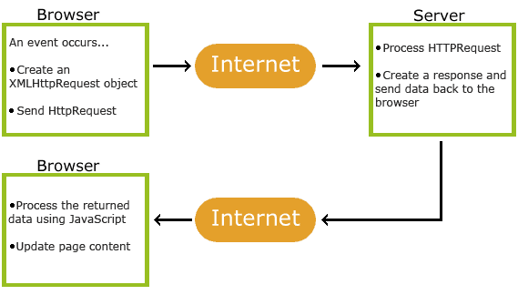

**9.5.1Rich Internet Application Technology**

AJAX is the most viable Rich Internet Application (RIA) technology so far. It is getting tremendous industry momentum and several tool kit and frameworks are emerging. But at the same time, AJAX has browser incompatibility and it is supported by JavaScript, which is hard to maintain and debug.

**AJAX is Based on Open Standards**

AJAX is based on the following open standards −

* Browser-based presentation using HTML and Cascading Style Sheets (CSS).
* Data is stored in XML format and fetched from the server.
* Behind-the-scenes data fetches using XMLHttpRequest objects in the browser.
* JavaScript to make everything happen.

**Advantages of AJAX**

* Reduce the traffic travels between the client and the server.
* Response time is faster so increases performance and speed.
* You can use [JSON](http://en.wikipedia.org/wiki/JSON)(JavaScript Object Notation) which is alternative to [XML](http://en.wikipedia.org/wiki/XML). JSON is key value pair and works like an array.
* You can use Firefox browser with an add-on called as Firebug to debug all Ajax calls.
* Ready Open source JavaScript libraries available for use – JQuery, Prototype, Scriptaculous, etc..
* AJAX communicates over [HTTP](http://en.wikipedia.org/wiki/Hypertext_Transfer_Protocol)Protocol.

**Disadvantages of AJAX**

* It can increase design and development time
* More complex than building classic web application
* Security is less in AJAX application as all files are downloaded at client side.
* Search Engine like [Google](http://en.wikipedia.org/wiki/Google) cannot index AJAX pages.
* JavaScript disabled browsers cannot use the application.
* Due to security constraints, you can only use it to access information from the host that served the initial page. If you need to display information from another server, it is not possible within the AJAX.

**9.6What is Bootstrap?**

Bootstrap is a sleek, intuitive, and powerful, mobile first front-end framework for faster and easier web development. It uses HTML, CSS and Javascript.

**9.6.1 History of Bootstrap**

Bootstrap was developed by *Mark Otto* and *Jacob Thornton* at *Twitter*. It was released as an open source product in August 2011 on GitHub.

**Why Use Bootstrap?**

* **Mobile first approach** − Bootstrap 3, framework consists of Mobile first styles throughout the entire library instead them of in separate files.
* **Browser Support** − It is supported by all popular browsers.



* **Easy to get started** − With just the knowledge of HTML and CSS anyone can get started with Bootstrap. Also the Bootstrap official site has a good documentation.
* **Responsive design** − Bootstrap's responsive CSS adjusts to Desktops, Tablets and Mobiles. More about the responsive design is in the chapter [Bootstrap Responsive Design.](https://www.tutorialspoint.com/bootstrap/bootstrap_responsive_utilities.htm)



* Provides a clean and uniform solution for building an interface for developers.
* It contains beautiful and functional built-in components which are easy to customize.
* It also provides web based customization.
* And best of all it is an open source.

**What Bootstrap Package Includes?**

* **Scaffolding** − Bootstrap provides a basic structure with Grid System, link styles, and background. This is is covered in detail in the section **Bootstrap Basic Structure**
* **CSS** − Bootstrap comes with the feature of global CSS settings, fundamental HTML elements styled and enhanced with extensible classes, and an advanced grid system. This is covered in detail in the section **Bootstrap with CSS**.
* **Components** − Bootstrap contains over a dozen reusable components built to provide iconography, dropdowns, navigation, alerts, pop-overs, and much more. This is covered in detail in the section **Layout Components**.
* **JavaScript Plugins** − Bootstrap contains over a dozen custom jQuery plugins. You can easily include them all, or one by one. This is covered in details in the section **Bootstrap Plugins**.
* **Customize** − You can customize Bootstrap's components, LESS variables, and jQuery plugins to get your very own version.

It is very easy to setup and start using Bootstrap. This chapter will explain how to download and setup Bootstrap. We will also discuss the Bootstrap file structure, and demonstrate its usage with an example.

## **Advantages of Bootstrap**

**Speed of Development**

The speed of development is one of its major advantages. If you want to develop an application or a website promptly, it is imperative to consider using Bootstrap. It helps to save your coding effort by offering less CSS functionality and pre-built blocks of code rather than structuring code from the scratch. Ready-made themes of Bootstrap will help achieve your needs through a faster route.

**Responsiveness**

According to CISCO’s predictions, global mobile data traffic will increase approximately 11-fold between 2013 and 2018. These statistics points to the need for a responsive website in varied kinds of mobile devices.

Bootstrap is equipped with responsive layout and 12-column grid system that help dynamically adjust the website to a suitable screen resolution. The ‘responsive utility classes’ feature of Bootstrap enables you to hide / show a certain section of content for a particular screen size.

**Consistency**

Consistency was the fundamental principle behind the introduction of Bootstrap. It ensures the ultimate consistency regardless of designer/developer, who is working on it. Moreover, the results work uniformly across various browsers and the output remains same.

**Customizable**

Bootstrap facilitates abundant customization and helps developers in designing tailor made websites, according to their specifications. It has the facility to select any feature that is actually needed to create a customized website. With this feature, one can get rid of what they do not require.

**Support**

Bootstrap helps to fix issues promptly with an immense support community. Bootstrap also releases continual updates to fix any new issues. Currently, it is being developed, hosted and maintained by GitHub with over 9000 commits and 500 contributors.

Bootstrap is an awesome framework with rich features. It is the latest in innovation for responsive development and supports designing of websites and apps faster, easier and better.

**10 About Back End:**

In a previous blog, we talked about how web programmers are concerned with launching websites, updates, and maintenance, among other things. All of that works to support the front-end of the website. The back-end has three parts to it: server, application, and database.

To better explain how all of this works, let’s use the example of a customer trying to purchase a plane ticket using a website. Everything that the customer sees on the webpage is the front-end, as we have explained before, but once that customer enters all of his or her information, ssssuch as their name, billing address, destination, etc, the web application stores the information in a database that was created previously on the server in which the website is calling for information.

The web application creates, deletes, changes, renames, etc items in the database. For example, when a customer purchases a ticket, that creates an item in the database, but when they have a change in their order or they wish to cancel, the item in the database is changed.

.In short, when a customer wants to buy a ticket, the backend operation is the web application communicating with the server to make a change in a database stored on said server. Technologies like PHP, Ruby, Python, and others are the ones backend programmers use to make this communication work smoothly, allowing the customer to purchase his or her ticket with ease.

**10.1 MySQL’s Logical Architecture**

The topmost layer contains the services that aren’t unique to MySQL. They’re services most network-based client/server tools or servers need: connection handling, authentication, security, and so forth.

.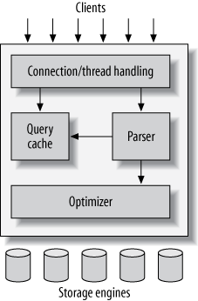

The third layer contains the storage engines. They are responsible for storing and retrieving all data stored “in” MySQL. Like the various filesystems available for GNU/Linux, each storage engine has its own benefits and drawbacks. The server communicates with them through the storage engine API. This interface hides differences between storage engines and makes them largely transparent at the query layer. The API contains a couple of dozen low-level functions that perform operations such as “begin a transaction” or “fetch the row that has this primary key.” The storage engines don’t parse SQL[[4](https://www.safaribooksonline.com/library/view/high-performance-mysql/9781449332471/ch01.html#ftn.CHP-1-FN-1)] or communicate with each other; they simply respond to requests from the server.

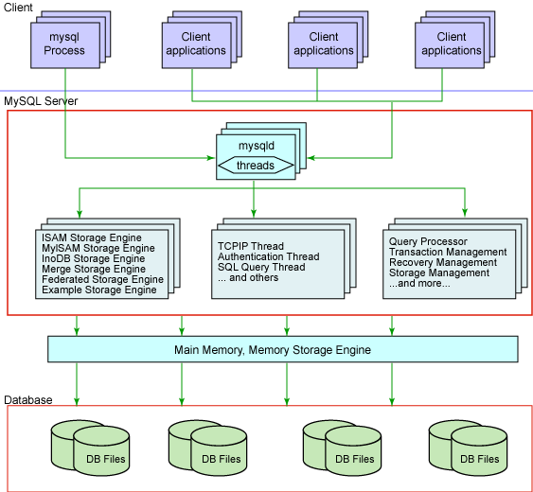

|  |
| --- |
|  |

**10.2 MySql:**

**What is MySQL?**

* MySQL is a database system used on the web
* MySQL is a database system that runs on a server
* MySQL is ideal for both small and large applications
* MySQL is very fast, reliable, and easy to use
* MySQL uses standard SQL
* MySQL compiles on a number of platforms
* MySQL is free to download and use
* MySQL is developed, distributed, and supported by Oracle Corporation
* MySQL is named after co-founder Monty Widenius's daughter: My

The data in a MySQL database are stored in tables. A table is a collection of related data, and it consists of columns and rows.

Databases are useful for storing information categorically. A company may have a database with the following tables:

* Employees
* Products
* Customers
* Orders

**10.2.1Introduction:**

The database has become an integral part of almost every human's life. Without it, many things we do would become very tedious, perhaps impossible tasks. Banks, universities, and libraries are three examples of organizations that depend heavily on some sort of database system. On the Internet, search engines, online shopping, and even the website naming

convention would be impossible without the use of a database. A database that is implemented and interfaced on a computer is often termed a database server.  
 One of the fastest SQL (Structured Query Language) database servers currently on the market is the MySQL server, developed by T.c.X. DataKonsultAB. MySQL, available for download at www.mysql.com, offers the database programmer with an array of options and capabilities rarely seen in other database servers. MySQL is free of charge for those wishing to use it for private and commercial use. Those wishing to develop applications specifically using MySQL should consult MySQL's licensing section, as there is charge for licensing the product.  


**These capabilities range across a number of topics, including the following:**

a) Ability to handle an unlimited number of simultaneous users.

b) Capacity to handle 50,000,000+ records.

c) Very fast command execution, perhaps the fastest to be found on the market.

d) Easy and efficient user privilege system.

However, perhaps the most interesting characteristic of all is the fact that it's free. That's right, T.c.X offers MySQL as a free product to the general public.

# 10.2.2 Reasons to Use MySQL

### **a) Scalability and Flexibility**

The MySQL database server provides the ultimate in scalability, sporting the capacity to handle deeply embedded applications with a footprint of only 1MB to running massive data warehouses holding terabytes of information. Platform flexibility is a stalwart feature of MySQL with all flavors of Linux, UNIX, and Windows being supported.

### **b) High Performance**

A unique storage-engine architecture allows database professionals to configure the MySQL database server specifically for particular applications, with the end result being amazing performance results.

**C) High Availability**

Rock-solid reliability and constant availability are hallmarks of MySQL, with customers relying on MySQL to guarantee around-the-clock uptime. MySQL offers a variety of high-availability options from high-speed master/slave replication configurations, to specialized Cluster servers offering instant failover, to third party vendors offering unique high-availability solutions for the MySQL database server.

### **d) Robust Transactional Support**

MySQL offers one of the most powerful transactional database engines on the market. Features include complete ACID (atomic, consistent, isolated, durable) transaction support, unlimited row-level locking, distributed transaction capability, and multi-version transaction support where readers never block writers and vice-versa.

**e) Web and Data Warehouse Strengths**

MySQL is the de-facto standard for high-traffic web sites because of its high-performance query engine, tremendously fast data inserts capability, and strong support for specialized web functions like fast full text searches.

### **f) Strong Data Protection**

Because guarding the data assets of corporations is the number one job of database professionals, MySQL offers exceptional security features that ensure absolute data protection. In terms of database authentication, MySQL provides powerful mechanisms for ensuring only authorized users have entry to the database server, with the ability to block users down to the client machine level being possible.

### **g) Management Ease**

MySQL offers exceptional quick-start capability with the average time from software download to installation completion being less than fifteen minutes. This rule holds true whether the platform is Microsoft Windows, Linux, Macintosh, or UNIX.

# PHP Main Features of MySQL

1. The MySQL Server design is multi-layered with independent modules.
2. Fully multi-threaded using kernel threads. It can easily use multiple CPUs if they are available.
3. Provides transactional and non-transactional storage engines.
4. Uses very fast B-tree disk tables with index compression.
5. Relatively easy to add other storage engines. This is useful if you want to provide an SQL interface for an in-house database.
6. A very fast thread-based memory allocation system.
7. Very fast joins using an optimized one-sweep multi-join.
8. In-memory hash tables, which are used as temporary tables.
9. SQL functions are implemented using a highly optimized class library and should be as fast as possible. Usually there is no memory allocation at all after query initialization.
10. The server is available as a separate program for use in a client/server networked environment.

**11. Xampp:-**

**XAMPP** ([/ˈzæmp/](https://en.wikipedia.org/wiki/Help:IPA/English) or [/ˈɛks.æmp/](https://en.wikipedia.org/wiki/Help:IPA/English))[[2]](https://en.wikipedia.org/wiki/XAMPP#cite_note-kaiseidlerinterview-2) is a [free and open-source](https://en.wikipedia.org/wiki/Free_and_open-source) [cross-platform](https://en.wikipedia.org/wiki/Cross-platform) [web server](https://en.wikipedia.org/wiki/Web_server) [solution stack](https://en.wikipedia.org/wiki/Solution_stack) package developed by Apache Friends,[[2]](https://en.wikipedia.org/wiki/XAMPP#cite_note-kaiseidlerinterview-2) consisting mainly of the [Apache HTTP Server](https://en.wikipedia.org/wiki/Apache_HTTP_Server), [MariaDB](https://en.wikipedia.org/wiki/MariaDB) [database](https://en.wikipedia.org/wiki/Database), and [interpreters](https://en.wikipedia.org/wiki/Interpreter_(computing)) for scripts written in the [PHP](https://en.wikipedia.org/wiki/PHP) and [Perl](https://en.wikipedia.org/wiki/Perl) [programming languages](https://en.wikipedia.org/wiki/Programming_language).[[3]](https://en.wikipedia.org/wiki/XAMPP#cite_note-x_mariadb-3)[[4]](https://en.wikipedia.org/wiki/XAMPP#cite_note-4) Since most actual web server deployments use the same components as XAMPP, it makes transitioning from a local test server to a live server possible.

XAMPP's ease of deployment means a [WAMP](https://en.wikipedia.org/wiki/WAMP) or [LAMP](https://en.wikipedia.org/wiki/LAMP_(software_bundle)) stack can be installed quickly and simply on an operating system by a developer, with the advantage that common add-in applications such as [WordPress](https://en.wikipedia.org/wiki/WordPress) and [Joomla!](https://en.wikipedia.org/wiki/Joomla!) can also be installed with similar ease using [Bitnami](https://en.wikipedia.org/wiki/Bitnami).

XAMPP is a software distribution which provides the Apache web server, MySQL database (actually MariaDB), Php and Perl (as command-line executables and Apache modules) all in one package. It is available for Windows, MAC and Linux systems. No configuration is necessary to integrate Php with MySQL.

## **Features**

XAMPP is regularly updated to the latest releases of [Apache](https://en.wikipedia.org/wiki/Apache_HTTP_Server), [MariaDB](https://en.wikipedia.org/wiki/MariaDB), [PHP](https://en.wikipedia.org/wiki/PHP) and [Perl](https://en.wikipedia.org/wiki/Perl). It also comes with a number of other modules including [OpenSSL](https://en.wikipedia.org/wiki/OpenSSL), [phpMyAdmin](https://en.wikipedia.org/wiki/PhpMyAdmin), [MediaWiki](https://en.wikipedia.org/wiki/MediaWiki), [Joomla](https://en.wikipedia.org/wiki/Joomla), [WordPress](https://en.wikipedia.org/wiki/WordPress) and more.[[9]](https://en.wikipedia.org/wiki/XAMPP#cite_note-addons-9) Self-contained, multiple instances of XAMPP can exist on a single computer, and any given instance can be copied from one computer to another.[[10]](https://en.wikipedia.org/wiki/XAMPP#cite_note-featuresCite-10) XAMPP is offered in both a full and a standard version (Smaller version).[[10]](https://en.wikipedia.org/wiki/XAMPP#cite_note-featuresCite-10)

## **Usage**

The most obvious characteristic of XAMPP is the ease at which a [WAMP](https://en.wikipedia.org/wiki/WAMP) webserver stack can be deployed and instantiated.[[11]](https://en.wikipedia.org/wiki/XAMPP#cite_note-PCW-review-2011-11) Later some common packaged applications that could be easily installed were provided by [Bitnami](https://en.wikipedia.org/wiki/Bitnami).[[12]](https://en.wikipedia.org/wiki/XAMPP#cite_note-Bitnami-friend-12)

Officially, XAMPP's designers intended it for use only as a development tool, to allow website designers and programmers to test their work on their own computers without any access to the Internet. To make this as easy as possible, many important security features are disabled by default.[[13]](https://en.wikipedia.org/wiki/XAMPP#cite_note-13) XAMPP has the ability to serve web pages on the [World Wide Web](https://en.wikipedia.org/wiki/World_Wide_Web).[[14]](https://en.wikipedia.org/wiki/XAMPP#cite_note-useage-14) A special tool is provided to [password-protect](https://en.wikipedia.org/wiki/Password) the most important parts of the package.[[15]](https://en.wikipedia.org/wiki/XAMPP#cite_note-15)

XAMPP also provides support for creating and manipulating databases in [MariaDB](https://en.wikipedia.org/wiki/MariaDB) and [SQLite](https://en.wikipedia.org/wiki/SQLite) among others.

Once XAMPP is installed, it is possible to treat a [localhost](https://en.wikipedia.org/wiki/Localhost) like a remote host by connecting using an [FTP](https://en.wikipedia.org/wiki/File_Transfer_Protocol) client. Using a program like [FileZilla](https://en.wikipedia.org/wiki/FileZilla) has many advantages when installing a [content management system](https://en.wikipedia.org/wiki/Content_management_system) (CMS) like [Joomla](https://en.wikipedia.org/wiki/Joomla) or [WordPress](https://en.wikipedia.org/wiki/WordPress)[[*further explanation needed*](https://en.wikipedia.org/wiki/Wikipedia:Please_clarify)]. It is also possible to connect to localhost via FTP with an [HTML editor](https://en.wikipedia.org/wiki/HTML_editor).

**12.SYSTEM ANALYSIS**

**System Analysis** is a management technique, which helps in designing a new system or improving an existing system. System Analysis is the process of gathering and interpreting facts, using information to recommend improvements to the system.

There are four basic elements of system analysis: -

* Output
* Input
* Files
* Processes

Analysis is a detailed study of the various operations performed by a system and their relationship within and outside the system. One aspect of analysis is defining the boundaries of the system anddetermining whether or not a candidate system should consider other related systems. During analysis, data are collected on the available files, decision points, and transactions handled by the current system.

**13. Identification Of Need**

In the present scenario most of the business organisations need an effectiveand efficient solution to overcome the problems of manually managingparking lots and parking records that leads to unnecessary timeconsumption. In the current competitive scenario every business establishment need an effective parking system to manage parking space effectively which will lead to customer satisfaction and increase in productivity. Keeping this in mind we propose Car Parking System. Car Parking System that provides operators an easy way of reserving a parking space for customers. It overcomes the problem of manually managing parking space and records that unnecessary consumes time. Hence this project offers a web based car parking system where operators can view various parking areas and select the space to view whether space is available or not. If the booking space is available then operator can book it for the customer. The booked space will be marked red and will not be available for anyone else until the customer is checked in. This system provides controls to both admin and operator and admin is the only person who manage(add, update, or delete) operators.

## **14. FEASIBILITY STUDY**

Feasibility is the determination of whether or not a project is worth doing. The process followed in making this determination is called a feasibility study. Once it has been determined that a project is feasible, the analyst can go ahead and prepare the project specification which finalizes project requirements.

Its main objective is not to solve the problem, but to acquire its scope. It focuses on following:

* Meet user requirements
* Best utilization of available resources
* Develop a cost effective system
* Develop a technically feasible system

There are three aspects of feasibility study:

* Technical Feasibility
  + - * EconomicalFeasibility
      * Operational Feasibility

**14.1 Technical Feasibility**

Technical feasibility centers around the existing system (hardware, software, etc) into what extent it can support the proposed addition.

The technical need of the System includes:

* The facility to produce outputs in a given time.
* Response time under certain conditions.
* Ability to process a certain volume of transaction at a particular speed.
* Facility to communicate data to distant location.

**Present system vs. Candidate system**

|  |  |  |
| --- | --- | --- |
| **CRITERIA** | **PRESENT SYSTEM** | **CANDIDATE SYSTEM** |
| **Growth potential** | Average(usually remains static) | Good (proposed system can be improved) |
| **Response time** | Average(increases with the increasing number of transactions) | Very good(takes few seconds to generate the output) |
| **User friendly** | Average(records maintained on papers) | Very good (it has an interactive interface that is GUI based) |

**14.2 Economical feasibility**

Economic analysis is the most frequently used method for evaluating the effectiveness of a candidate system. This procedure is to determine the benefits and savings that are expected from a candidate system and compare it with costs.

**Present system vs. candidate system**

|  |  |  |
| --- | --- | --- |
| **CRITERIA** | **PRESENT SYSTEM** | **CANDIDATE SYSTEM** |
| **System development** | One person handles the candidate record that appears the reports.  One person handles the candidate record that generates the queries.  One person handles those records those are used producing reports. | One computer system can do a work of more than ten (10) people. |
| **System operation** | Fair | Very good |
| **Payback** | Hectic | Good |

**14.3Operational Feasibility**

Employees of any organization are inherently resistant to change because they believe it will be very difficult to adapt in the new system. Computers have been known to facilitate change. It is well known that computerization has something to do with transfers, turnover, retraining, and changes in employee job status.

**Present system vs. candidate system**

|  |  |  |
| --- | --- | --- |
| **CRITERIA** | **PRESENT SYSTEM** | **CANDIDATE SYSTEM** |
| **Operation time** | The present system takes more preparation hours. | The candidate system takes less operation hour in comparing to present system. |
| **Reliability** | Human beings are more error prone so it is less reliable. | The candidate system is more reliable than the present system. |
| **Retrieval** | 1hr or more. | Few seconds. |
| **Regularity** | There is no regularity of maintaining records procedures. Some time the records are updated monthly some time yearly. | The candidate system is regularly updated. |

**SRS (SYSTEM REQUIREMENT SPECIFICATION)**

**Definitions-**

|  |  |
| --- | --- |
| **Terms** | **Definitions** |
| **Slots** | Uniform length and width spaces that is intended to park vehicles |
| **Basement** | Large space consistsof multiple number of parking slots |
| **Database** | Collection of all information monitored by this system |
| **Field** | A cell within a form |
| **User** | Administrator/operator |
| **Software requirement specification** | A document that completely describes all the functions of proposed system and constraint under which it operate. For example this document. |
| **Developer** | Members of the system developing team |
| **Operator** | User who will operate the system for customers |

**Overview-**

next chapter the overall description section of this document gives an overview of functionality of the product. It describes the informal requirements and is used to establish a context for technical requirements specification in the next chapter. The next chapter specific requirement section is written primarily for developers and describes in technical terms the details of functionality of the product.

Next section following specific requirements gives a description of model used in analysis to understand the flow of system development that also consists of data flow diagrams to describe the flow of data or information inside the system.

**15.1 General Description**

**Product Perspective-**

The Car ParkingSystem is intended to replace the manual model of checked in car record keeping by means of paper records. The paper records are replaced with a single interaction between the user(which can be either operator or administrator) and the system.

**Products Functions-**

Car Parking System will take attribute of the car, car registration number as input and make record of it in the database, it will generate the output as required by the user, and this can be accomplished by either the administrator or the operator.

**User Characteristics-**

The user is expected to be windows literate and to be able to use windows, pull down menus and similar tools in order to be able to generate output from the system. And the user can be either operator or administrator.

**General Constraints-**

System working depends on the system’s time and date, it should be correct every time the system operates. This system requires a user at the system place whenever the parking record is to be made, the operator can be the administrator or operator. Addition, deletion, updation of the cars, operators, slots and the login table can only be done by the administrator and no other user of the system.

**Assumptions and Dependencies-**

it is assumed that the input to the system is correct by the user of the system. System also depends on the basic computer knowledge of the computers of the users of the Car Parking System.

**15.2 Specific Requirements**

**External Interfaces**

**User Interfaces**:- Keyboard, Mouse and Printer.

**Hardware Interfaces:-**

* **Operating system-** Microsoft XP or above
* **Main Memory-**1 GB or more
* **Hard Drive Capacity-** 80 GB or more

**Communications Interfaces: -** The user will interact with the system through the monitor of the computer.

The system will directly communicate to the local database of the computer residing in the same computer in which the system is installed.

**Software Interfaces:-**

* This software will transmit the parking entry made regarding check-in, check-out by the user to the database residing in the same computer where the software is installed.
* Admin will be allowed to make changes to the database as per requirements.
* The System will allow administrator only to manipulate the login, register, slot and checkinout table.

**16. HARDWARE AND SOFTWARE REQUIREMENT**

**16.1 Hardware Requirements: -**

**Following are minimum requirements**

1. Processor: i3 or more.

2. RAM: 2GB or more.

3. HDD: 80 GB.

5. 14’’ SVGA color Monitor or 15’’ LCD monitor or higher end monitor.

6. Mouse

7. Keyboard: Normal or Multimedia.

8. Printer

**16.2 Software Requirements: -**

**Operating System:** Microsoft Windows XP or above

**Software:**

1. WAMP Server.
2. Database –mysql.
3. Browser.

**17.Use Case Diagram**

A diagram is a visualization of set of elements and the relationships between them. Use case is a set of scenarios, which defines functionalities of the system from a user’s perspective.

The main components of a use case diagram include actors, use cases and their relationships. They depict the interaction between actors and system to achieve certain goal. This, a use case diagram is important in modelling the behavior of a system.

**Actor:** A coherent set of roles that users of use cases play when interacting with the use cases.

**Use Case:** A description of sequence of actions, including variants, that a system performs that yields an observable result of value of an actor.

**Use Case Diagram for Car Parking**

**17.1 Use case for Admin:**

Admin

**Use cases Description for Administrator:**

I have identified a set of use cases based on the functionalities and goals of the application.

**Actors:**

The following actor interacts and participant in this use case: Administrator.

• **Login-** This use case denotes a set of actions required for Admin to login

into the application.

• **Add Operator-** This use case allows the actor with role ‘Admin’ to maintain or add the operator.This includes adding operator information in system

• **Delete Operator** This use case allows the actor with role ‘Admin’ to maintain operator. This includes deleting operator information from the system.

• **Checkin-** This use case allows the actor with role ‘Administrator’ to manage feedback. This includes adding, changing and deleting feedback related information from the system.

**• Checkout-** This use case denotes a set of actions related to database maintain by Administrator.

**• Enquiry-** This use case denotes to get information about the car parked

**Actors:**

The following actor interacts and participant in this use case: Data entry operator (Admin).

• **Add, Update, Delete, Category-** This use case denotes a set of actions required for Operator

• **Get Enquiry-** This use case allows the actor with role ‘Admin’ to see report. This includes adding and deleting report information from the system.

• **Enter Details of operator-** This use case allows the actor with role ‘Admin’ to insert details of Operator .

**17.2 Use Case for Operator:**

**Use cases Description Operator:**

I have identified a set of use cases based on the functionalities and goals of the application.

**Actors:**

The following actor interacts and participant in this use case: Jobseeker.

• **Login-** This use case denotes a set of actions required for Operator to login

into the application.

• **Select Basement-** This use case allows the actor with role ‘Operator’ to select Basement for parking

•. **Select slot-** This use case denotes a set of actions required for operator to search available slot for the cars.

•. **Checkin-** This use case allows the actor with role ‘operator’ to manage feedback. This includes adding, changing and deleting feedback related information from the system.

**• Checkout-** This use case denotes a set of actions related to database maintain by .

**• Enquiry-** This use case denotes to get information about the car parked

**Actors:**

The following actor interacts and participant in this use case: Recruiter.

• **Login-** This use case denotes a set of actions required for Operator to login

into the application.

**18. System Design**

System designs are modeled using UML which is a standard object-oriented analysis and design language. The UML is a collection of diagrams and standard set of notations for specifying and visualizing various aspects such as requirements and design of software systems.

Systems design is the process of defining the architecture, components, modules, interfaces, and data for a system to satisfy specified requirements .

The primary objective of the design, of course, is to deliver the requirements as specified in the feasibility report. In general, the following design objectives should be kept in mind:

* **Practicality:**  The system must be stable and can be operated by people with average intelligence.
* **Efficiency:** This involves accuracy, timeliness and comprehensiveness of the system output.
* **Cost:** It is desirable to aim for a system with a minimum cost subject to the condition that it must satisfy all the requirements.
* **Flexibility:** The system should be modifiable depending on the changing needs of the user. Such modifications should not entail extensive reconstructing or recreation of software. It should also be portable to different computer systems.
* **Security:** This is very important aspect of the design and should cover area of hardware reliability, fall back procedures, physical security of data and provision for detection of fraud and abuse.

INPUT OUTPUT

DESIGNING

INPUTS ARE (SRS, DESIGN CRITERIA)

OUTPUTS ARE (DFD’s, FLOW CHART, E-R DIAGRAMS

**18.1 CONCEPTUAL DESIGN**

The conceptual design tells the customer what the system will do. The system is described in terms of its boundary, entities, attributes, and relationships. In the conceptual designing phase we have considered the following questions: -

1. Where will the data come from?
2. What will happen to it in the system?
3. What will the system look like to user?
4. What choices will user are offered?
5. What will the reports and screen look like?

**18.2 TECHNICAL DESIGN**

The technical design explains the system to those hardware and software experts who will implement it. The design describes the hardware configuration, the software needs, the communication interfaces, the input and output of the system and anything else that translates the requirements into a solution to the customer’s problem. The design description is a technical picture of the system specification. Thus we include the following items in the technical design:

1. The system architecture: - a description of the major hardware components and their functions.
2. The system software structure: - the hierarchy and function of the software components.
3. The data :- the data structure and data flow.

**18.3 STRUCTURED DESIGN**

Structured design is a data flow based methodology. The approach begins with the system specification that identifies inputs and outputs and describes the functional aspects of the system. The specifications then are used as a basis for the graphic representation. The next step is the definition of the modules and their relationships to one another in form called a structure chart, using a data dictionary and other structured tools.

A design is said to be top-down if it consists of a hierarchy of modules, with each module having a single entry and a single exit subroutine. The primary advantages of this design are as follows:

* Critical interfaces are tested first.
* Early versions of the design, though incomplete, are useful enough to resemble the real system.
* Structuring the design, parse, provides control and improves morale.
* The procedural characteristics define the order that determine processing.

**19. DATABASE DESIGN**

A database is a collection of related information or data. Paper based database that you already use may include a telephone book, a mailing list or a set of personal records.

A database is an organized collection of data. Thus it is a collection of information organized and presented to serve an assigned purpose.

In a typical database, one needs to perform several operations, such as adding new information, modifying existing information, arranging information in a desired order, removing unwanted or outdated information. A computerized database that can perform such functions is known as a “DATABASE MANAGEMENT SYSTEM” or DBMS for short.

**It’s Features: -**

1. The table is a list of related data (such as names, addresses, etc.). A table can also be visualized as a 2-D matrix that has a series of rows & columns. A column represents a single type of data about an entity but a row is a collection of data for each column in a table.
2. Each column contains a category of data. In a table, each category of data is called a field.
3. Each row contains a unit of data pertaining to one person. In a table, a unit of data is called a record. The row is also known as the Tuple of the Database.

**Database design table**

1. **Log In Table**

|  |  |  |
| --- | --- | --- |
| **Column Name** | **Data Type** | **Description** |
| Username | Varchar | Username of the operator |
| password | Varchar | Password of the operator |
| logindate | Varchar | Login date |
| logintime | Varchar | Login time |
| logoutdate | Varchar | Logout date |
| logouttime | Varchar | Logout time |

1. **Register Table**

|  |  |  |
| --- | --- | --- |
| **Column Name** | **Data Type** | **Description** |
| Id | Int | Id of the operator |
| Firstname | Varchar | Firstname of the operator |
| Lastname | Varchar | Lastname of the operator |
| DOB | Varchar | Date of birth |
| Age | Int | Age of the operator |
| Contact | Varchar | Contact number of the operator |
| Email | Varchar | Email of the operator |
| Username | Varchar | Username of the operator |
| Password | Varchar | Password of the operator |
| Address | Varchar | Address of the operator |
| Gender | Varchar | Gender of the operator |

1. **Floor Table**

|  |  |  |
| --- | --- | --- |
| **Column Name** | **Data Type** | **Description** |
| floor_id | varchar | Id of floor |
| no_of _slots | Int | Number of slots in each floor |

1. **Slot Table**

|  |  |  |
| --- | --- | --- |
| **Column Name** | **Data Type** | **Description** |
| Slotid | Varchar | Id assigned to slots |
| Floorid | Varchar | Id assigned to floors |

1. **Admin Table**

|  |  |  |
| --- | --- | --- |
| **Column Name** | **Data Type** | **Description** |
| Id | Int | Id of the admin |
| Name | varchar | Name of thethe admin |
| Contact | varchar | Contact number of the admin |
| Email | varchar | Email id of the admin |
| Address | varchar | Address the admin |
| Username | varchar | Username of the admin |
| Password | varchar | Password of the admin |

1. **Checkinout Table**

|  |  |  |
| --- | --- | --- |
| **Column name** | **Data type** | **Description** |
| Carno | varchar | Car registration number |
| Date | varchar | Date on which particular car is parked |
| Slotid | varchar | Id of the slot |
| Floorid | varchar | Id of the floor |
| Intime | varchar | Time when car is parked in  Or checked in |
| Outtime | varchar | Time when car is parked out or check out |
| Status | varchar | Status of slots |

# 20.E-R DIAGRAM

Data models are tools used in analysis to describe the data requirements & Assumptions in the system from a top-down perspective .They also set stage for the design of databases Later on the SDLC.

There are three basic elements in E-R Models:

a. Entities are **things** about which we seek information

b. Attributes are the data we collect about the entities.

c. Relationships provide the structure needed to draw information from multiple entities.

# DEVELOPING AN E-R DIAGRAM

Developing an E-R Diagram require an understanding of the system & its components before discussing the procedure; let’s look at a narrative created by us.

**E-R Diagram**

Login

Admin

Has

Manages

provides

Operator

slots

Views

Records

Car info

Bookings

**21.DATA FLOW DIAGRAM**

The DFD was first developed by **“LARRY CONSTANTINE”** as a way of expressing system requirement in Graphical form.

A DFD is known as a “BUBBLE CHART”.

System requirement & identifying major transform that will become program in system design. A DFD consists of series of bubble joined in line. The bubble represents data transformation & the line represents the flow of data

**21.1 SYMBOLS USED IN DATA FLOW DIAGRAM**

- source rect angle, which defines our destination

- Arrow, which shows dataflow.

- Circle, which represent a process that transforms incoming data

Into outgoing flow.

-Open rectangle, which shows a data store.

**0-LEVEL DFD**

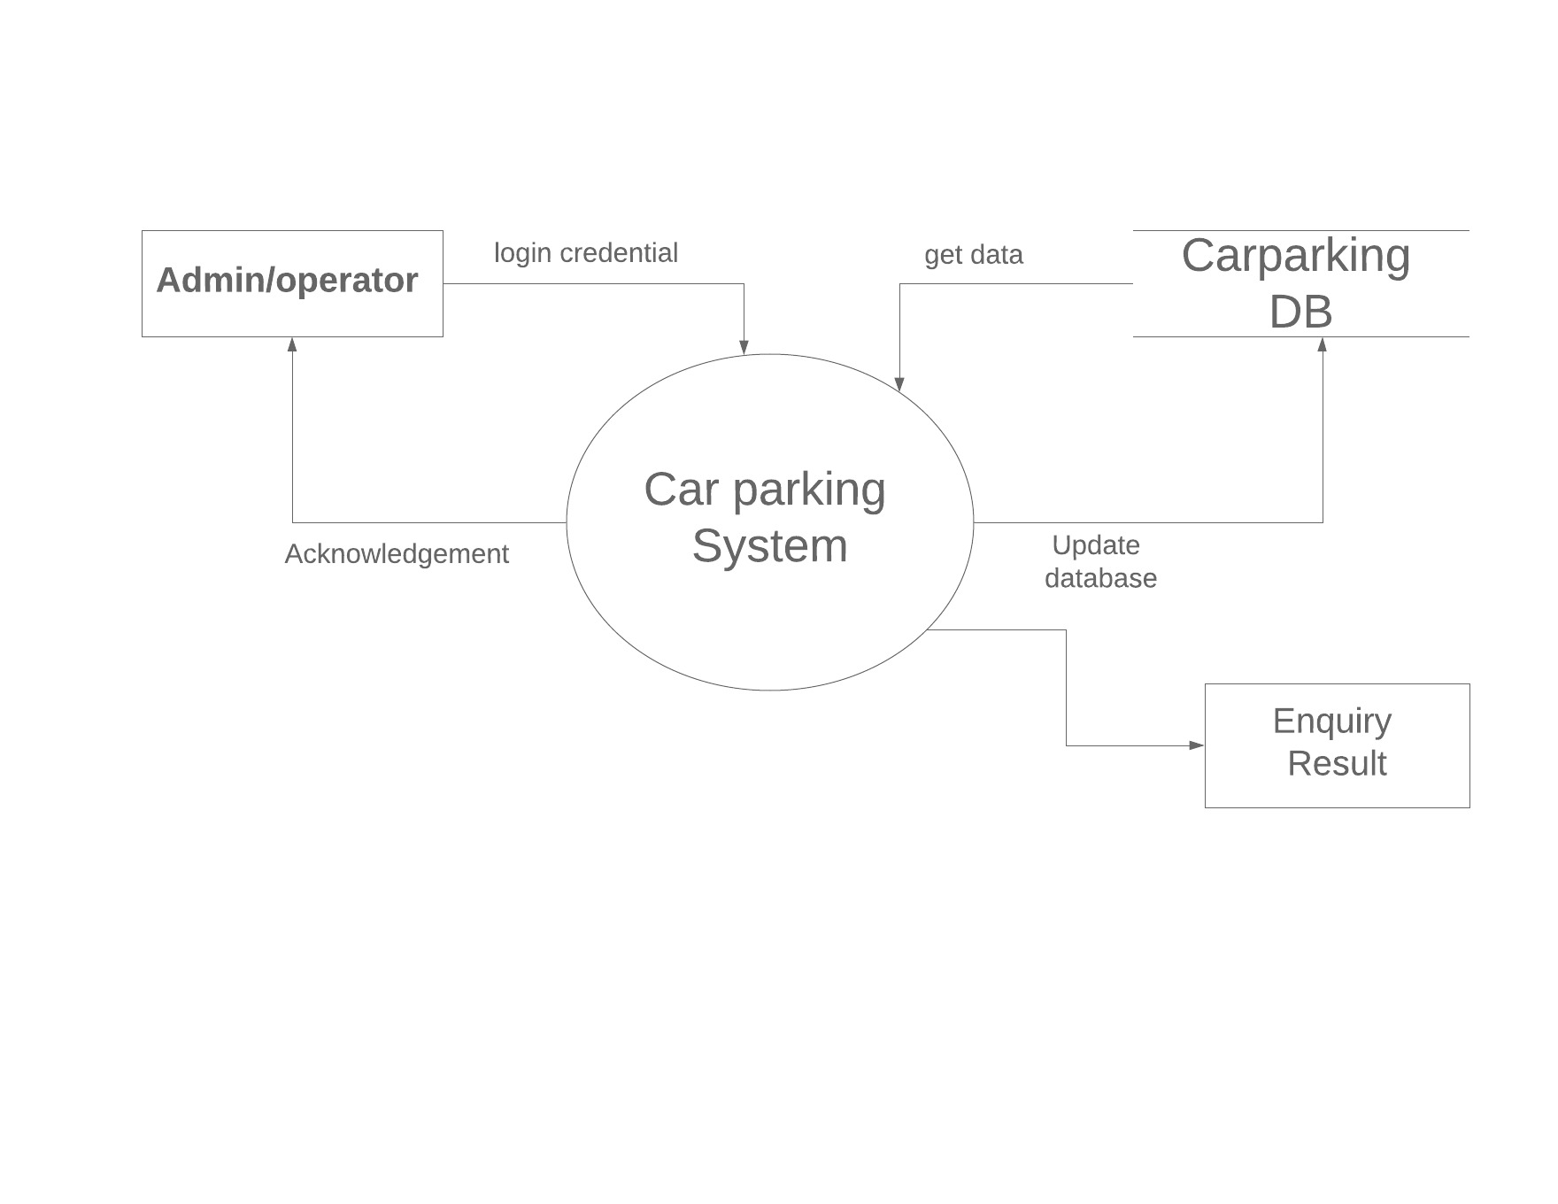

**1-LEVEL DFD**

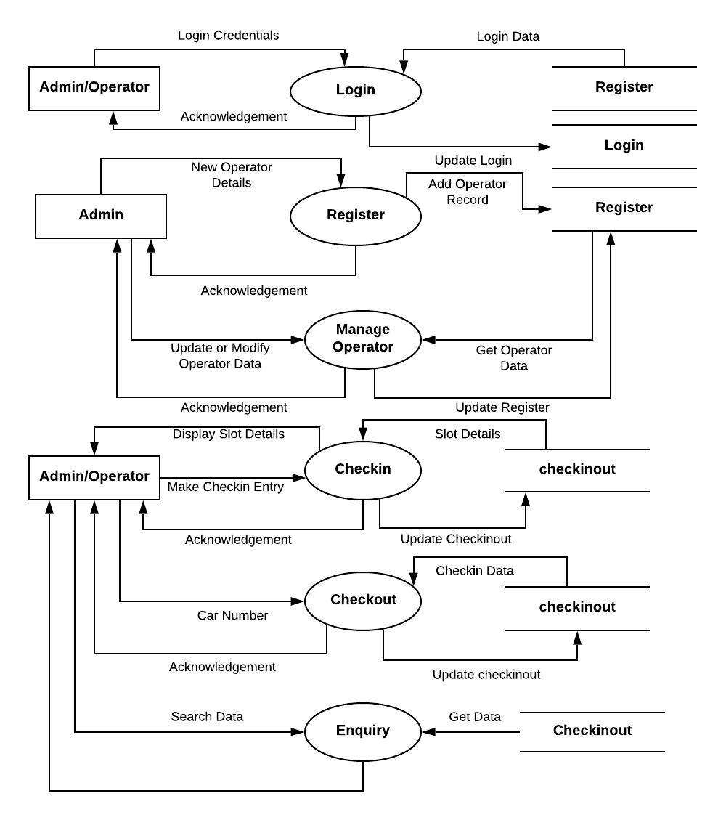

**2-LEVEL DFD**

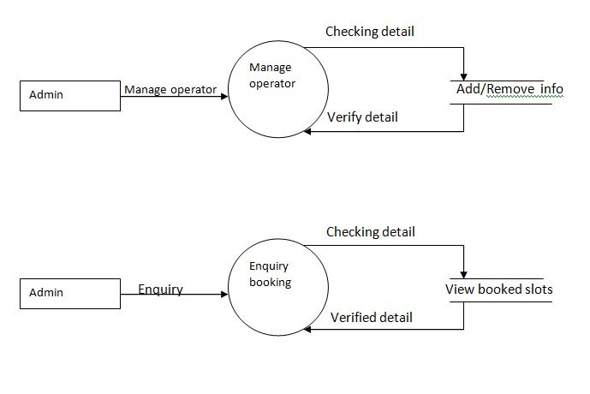

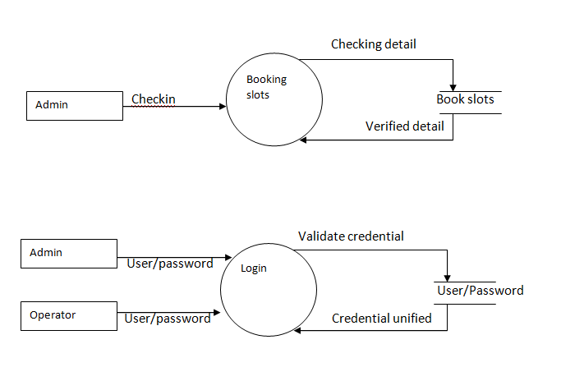

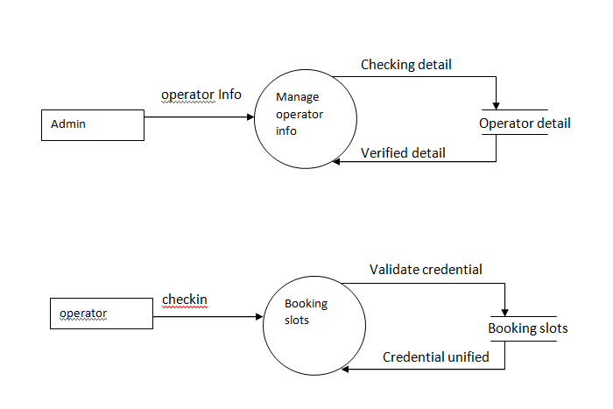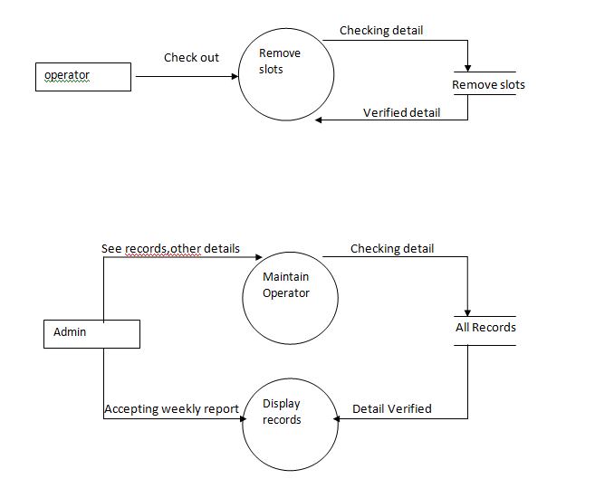

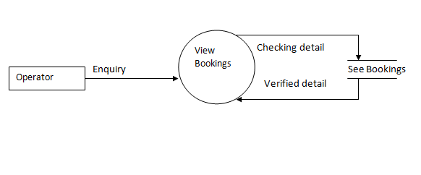

**Website Pages:**

**Log in Page:**

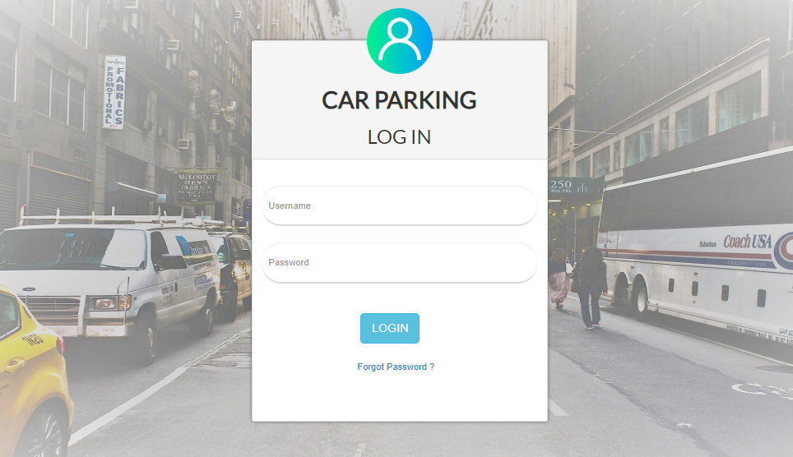

# Forget password form

**1-Security question**

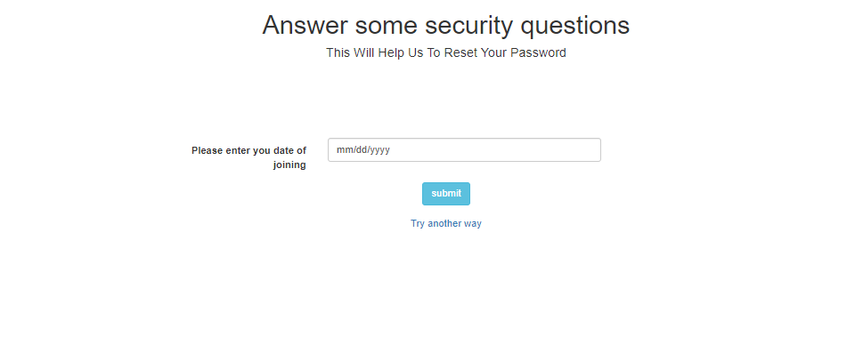

# Forget password form

**2-Security question**

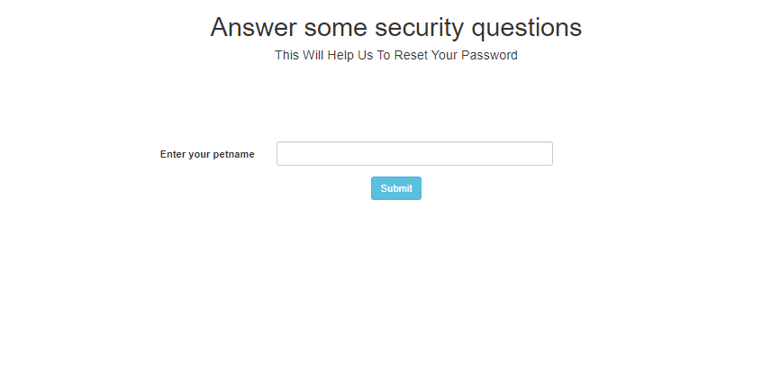

# Change password

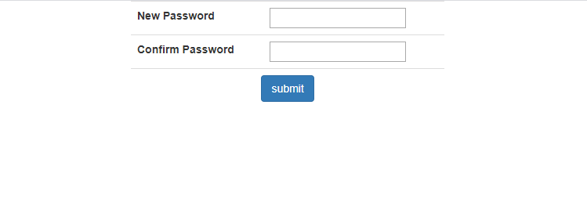

**Admin home page:**

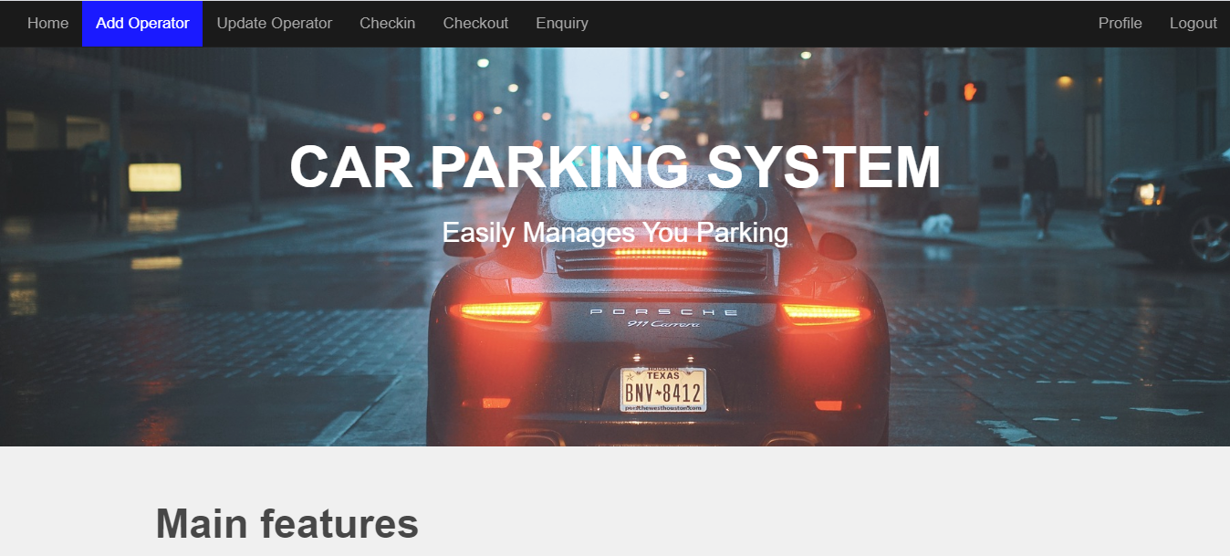

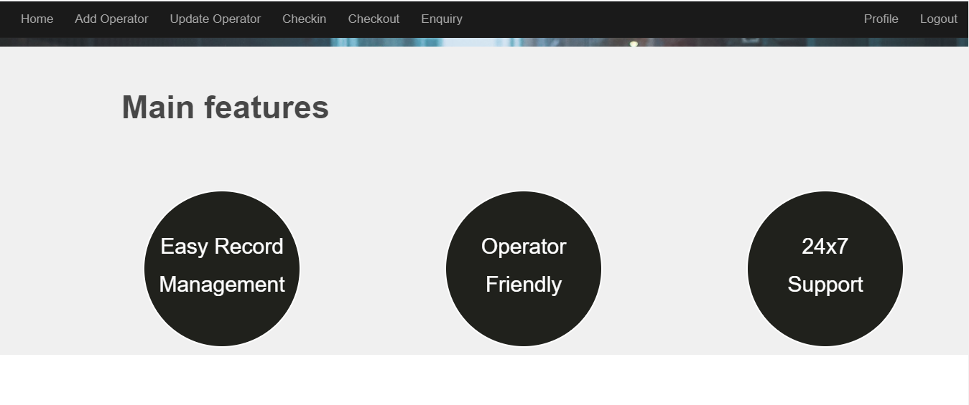

**Admin Add Operator form:**

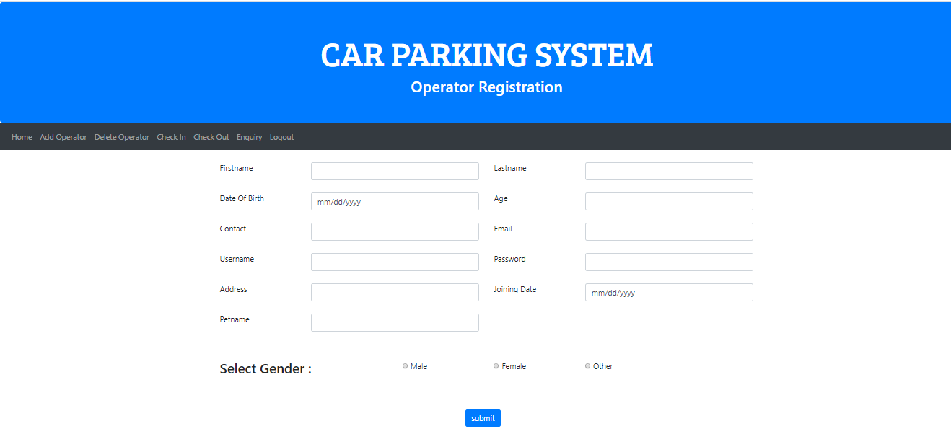

# Admin Update operator page:

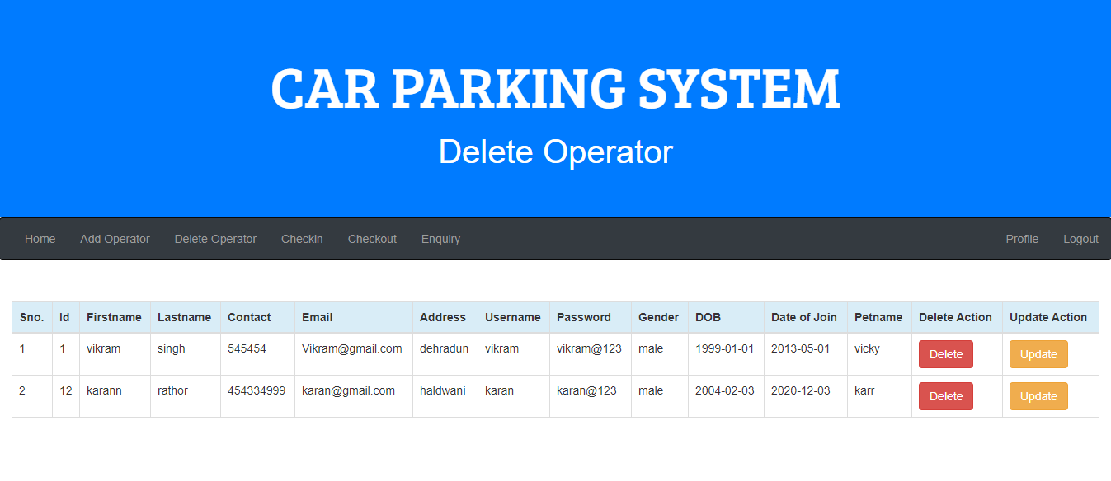

**Checkin page:**

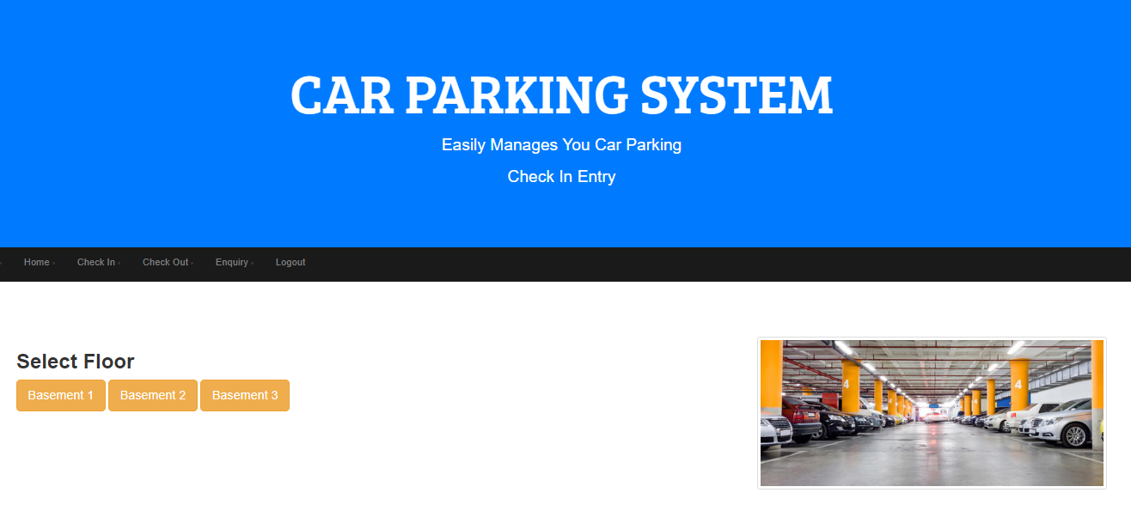

**Basemnet 1 slots Available :**

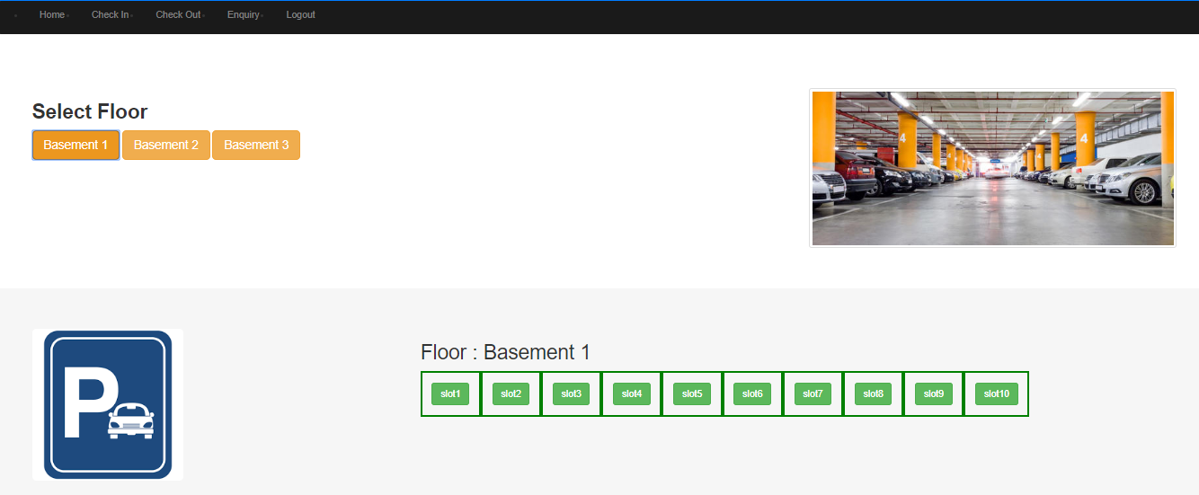

**All slots Available:**

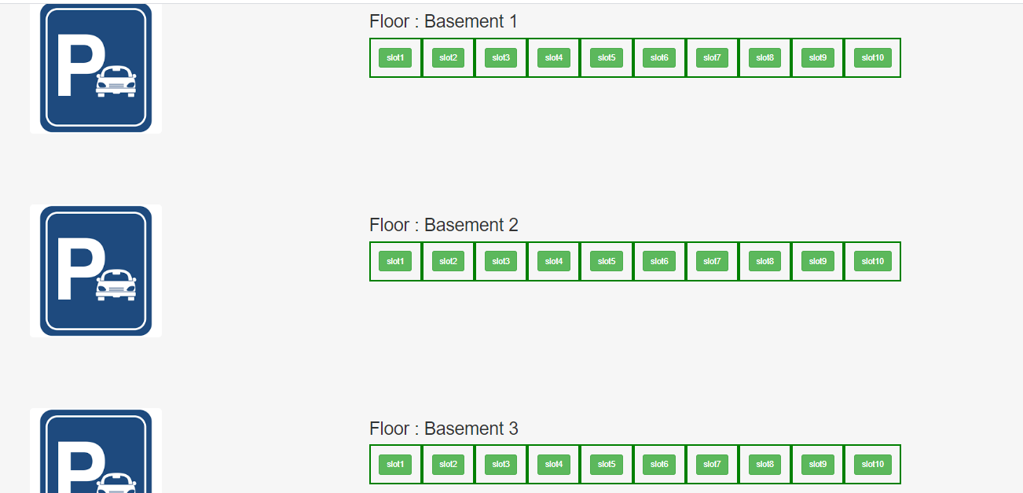

**CheckOut Page:**

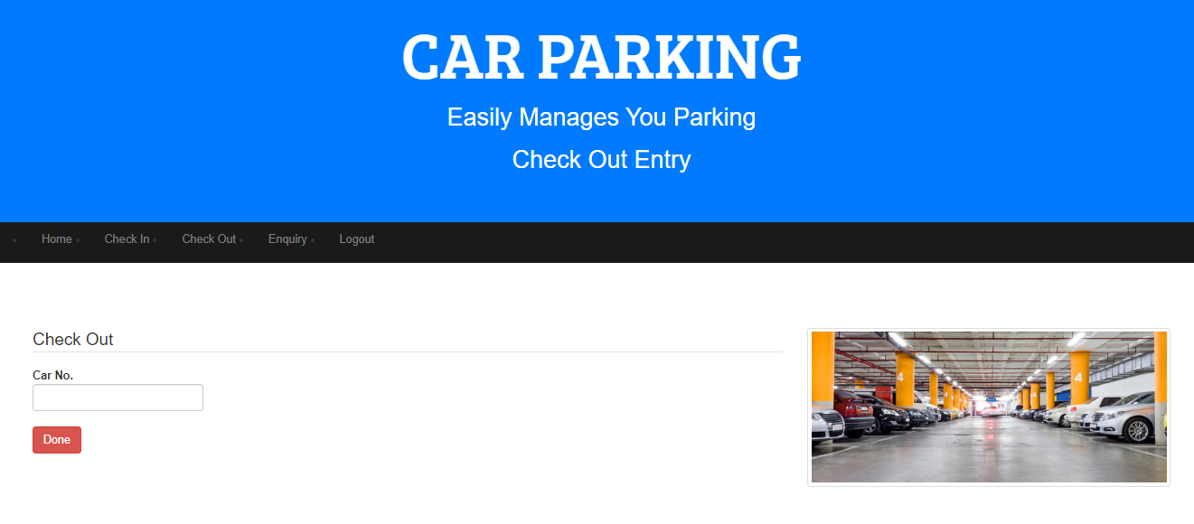

**Operator home page:**

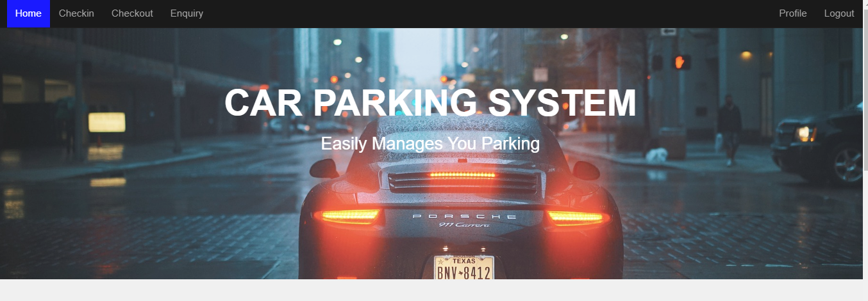

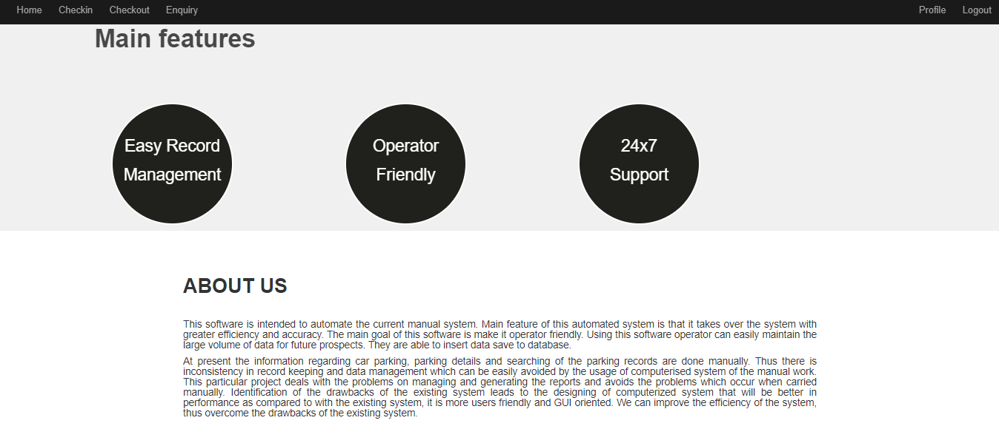

**Profile Info:**

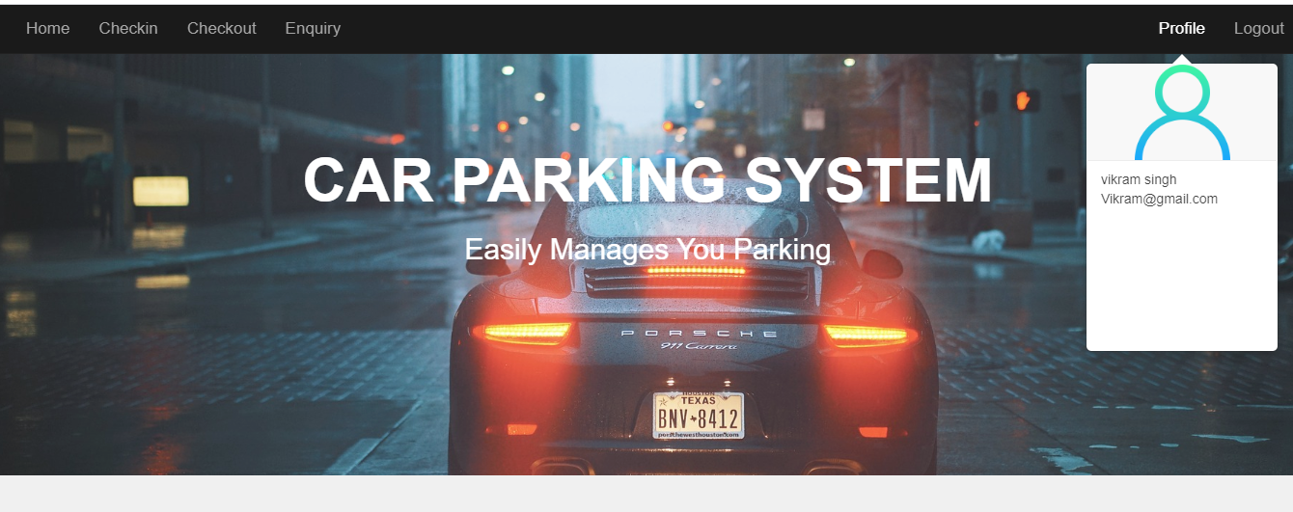

**Enquiry page:**

**Enquiry based on currently parked car:**

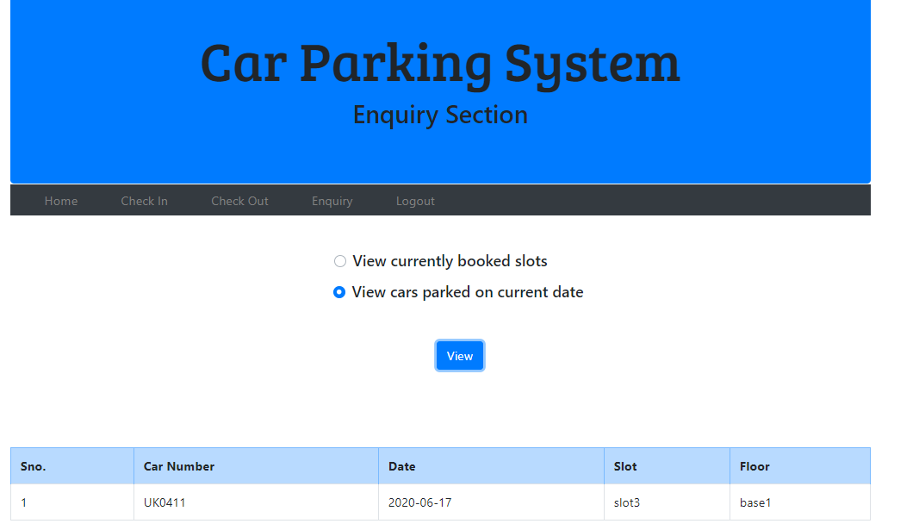

**Enquiry page:**

**Enquiry based on currently book slot:**

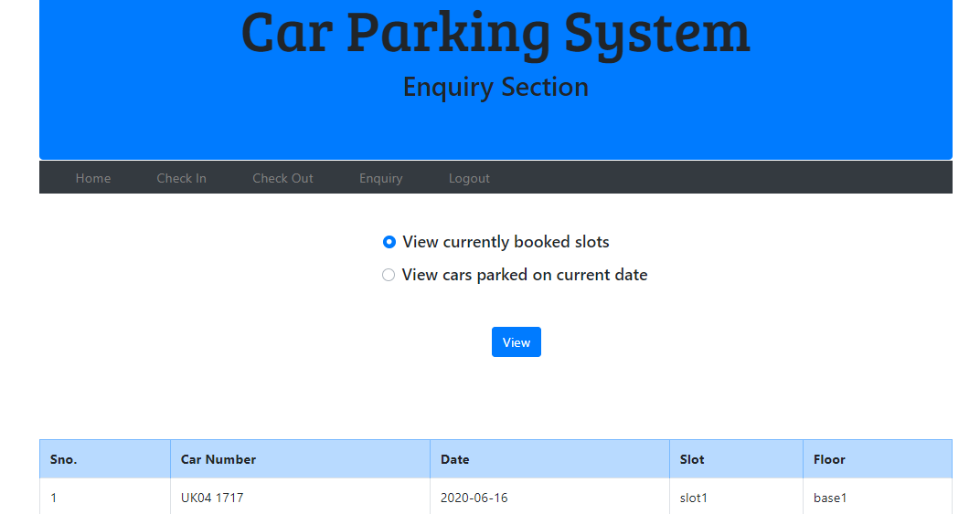

**Database of the car parking system:**

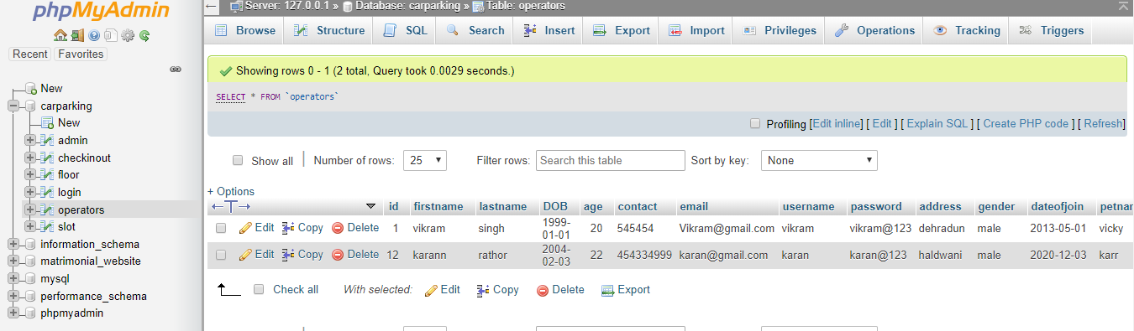

**23. Advantages of carparking system implementation:**

The smart parking system is considered beneficial for the car park operators, car park patrons as well as in environment conservation ([Shaheen *et al*., 2005](https://scialert.net/fulltext/?doi=itj.2009.101.113#4476_an); [Chinrungrueng *et al*., 2007](https://scialert.net/fulltext/?doi=itj.2009.101.113#2640_con)). For the car park operators, the information gathered via the implementation of the Smart Parking System can be exploited to predict future parking patterns. Pricing strategies can also be manipulated according to the information obtained to increase the company’s profit. In terms of environment conservation, the level of pollution can be reduced by decreasing vehicle emission (air pollutant) in the air ([Shaheen *et al*., 2005](https://scialert.net/fulltext/?doi=itj.2009.101.113#4476_an)). This can be attributed to the fact that vehicle travel is reduced. As fuel consumption is directly related to vehicle miles travelled, it will be reduces as well.

Patrons are also able to benefit from smart parking system as parking space are able to be fully utilized ([Kurogo *et al*., 1995](https://scialert.net/fulltext/?doi=itj.2009.101.113#2672_con); [Sakai *et al*., 1995](https://scialert.net/fulltext/?doi=itj.2009.101.113#2633_con)) with a safer ([Shaheen *et al*., 2005](https://scialert.net/fulltext/?doi=itj.2009.101.113#4476_an); [Chinrungrueng *et al*., 2007](https://scialert.net/fulltext/?doi=itj.2009.101.113#2640_con)), optimized and more efficient system implemented ([Sakai *et al*., 1995](https://scialert.net/fulltext/?doi=itj.2009.101.113#2633_con); [Shaheen *et al*., 2005](https://scialert.net/fulltext/?doi=itj.2009.101.113#4476_an)). The system is made more efficient as vehicle travel time and search time are significantly reduced due to the information provided by the smart parking system. With the information provided, drivers are able to avoid car park that are fully occupied and locate vacant parking spaces with ease elsewhere. The number of vehicles parked illegally by the roadside which leads to traffic congestion is also reduced as it is absorbed into the car parks ([Kurogo *et al*., 1995](https://scialert.net/fulltext/?doi=itj.2009.101.113#2672_con)). Most importantly, traffic congestion can be reduced. All this would eventually lead to convenience for the patrons.

**24. FINAL RESULT AND CONCLUSION**

The title of our project is **“Car Parking System**” .This project fulfills most of the requirements of the customer of this system. As the final results of this system we get the outputs as required by the organizers.

This manage parking records very efficiently without much manual effort. It can show the status of each car slot within no time. Various types of options are there to get the data as and when required.

We have tried our level best to ensure that the system is full proof and complete, yet some errors and problems may still be present as nothing can be 100% perfect in this world. Some future enhancements may still be required in this project for the sake of its completeness and accuracy.

**25. LIMITATION OF OUR PROJECT**

* GUI is only in English.
* It requires large database.

**26.FUTURE SCOPE OF OUR PROJECT**

* To enhance the software so that it can be used in a networked environment.
* Easy to implement anywhere
* Can have multiple or broad user in near future

**27. BIBLIOGRAPHY**

Software Engineering – K.K. Agarwal

Software Engineering – Rajib mall

**28.References:**

[**www.http://w3school.com**](http://www.http://w3school.com)

[**www.http://tutorialspoint.com**](http://www.http://tutorialspoint.com)